ConTroll Registration System  
Exhibitor Module Documentation

### Introduction

The Exhibitor Module is designed to support for four types of exhibitors:

* Artists / Art Shows
* Exhibitors / Exhibit Hall
* Fan Events / Fan Tables
* Dealers (Vending) / Vendor Rooms (Dealers Room, … )

At present only Art Shows and Dealers Rooms are supported and the other two will be coming in a future release, but the same ideas belong to all of them.

The module is split into two parts:

* Back end: housed in the ConTroll controll back end under the Exhibitors Tab.
  + Configure the spaces and offerings within the spaces
  + Edit “Custom Text”
  + Manage each exhibitor space
    - Add/edit/view exhibitor information
    - Add new space requests for mail in applications for space and process mail in payments
    - Approve exhibitor portal requests for space
    - View current status of all requests
  + Exhibits Administrators are granted permission to access this tab in the ConTroll back end.
* Front end: A portal for the exhibitor to:
  + request space
  + pay for the space and discounted memberships (if any)
  + if the space uses inventory control: manage the inventory of what they are bringing/selling.

# Exhibitor Venue Configuration

Exhibitor Venue configuration is broken down into a hierarchy of five items you will need to configure:

1. Region Types - A place to hold the rules and parameters for the different types of exhibit regions (places)
   * Rules and parameters for a type of exhibit venue, such as art shows, exhibit halls, dealers rooms, etc.
   * Multiple venues can be of the same type
   * This data is persistent from convention year to convention year and only entered once.
2. Regions - the actual exhibit venues
   * Which type of region
   * Description of the region
   * This data is persistent from convention year to convention year and only entered once.
   * A region does not have to exist every year. Regions not being used this year are just not created in the “Region Years” tab.
3. Regions for this Year - which regions (exhibit venues) are active this convention year
   * Specific information for this venue for this convention year
   * Designed to handle information that probably changes from year to year
4. Spaces within the Region - variations of spaces within the exhibit venue (for this year)
   * Details on the types of space available within the region
   * Examples:
     + Tables
     + Panels,
     + Open floor space

Anything you wish to allocate to exhibitors.

1. Space Pricing Options (for this space, for this year)
   * Options the exhibitor can request for each Space
   * The exhibitor can not specify a quantity of an option, just the option
   * The exhibitor can only request one option for each space within a region, but can request an option for each space in a region (exhibit venue)
   * Options might be 1 Panel, 2 Panels, 3 Panels. The quantity is specified directly in the option

### Persistence From Year to Year

While exhibitors will enter their data once for the exhibitor portals, just as members enter their personal data once in the registration portal, and it will persist from year to year.

Likewise the rules (Region Types) and the exhibit venues (Regions) persist from year to year.

As part of the rollover of the system from one convention year to another, ConTroll will try to create the annual items (Regions for this Year, Spaces within the Region, and Space Pricing Options) from the prior year. You are responsible for checking all of those and making sure they are correct and don’t require any changes for the new year.

If a region is not going to be used this year, you need to delete the data for that region year, space, and space price options.

### General Ledger Numbers/Labels

All annual items have places for the entry of General Ledger Numbers and Labels. This is used in the accounting side of the system. The GL Number is passed into Square and can be imported from there into QuickBooks. The GL Number and Label can be used in reports.

Some of the General Ledger items are labeled with ‘Default’ on the front. This means this is a default value that will be used to populate new rows entered into the next level down.

So when you enter a Default GL Num or Default GL Label in Regions for this Year, this default value is used for any new rows added to the Spaces within the Region. Likewise the column in Spaces within the Region is used as a default value for any new Space Pricing Options.

However, changing the default value will not cause any existing rows of the next level down to change. You must edit that data specifically if you want it to be changed.

### Exhibitor Portals

The exhibitor portal is different from the registration portal. Using the appropriate exhibitor portal exhibitors can request space in any or all of the regions you configured.

**NOTE**: The current version only supports Artist and Vendor portals and venue types. In a future release Exhibit Hall and Fan Tables will be added to the system.

### Organizing Your Conventions Exhibitor Venues into ConTroll Venues

It is up to each convention to decide how they want to organize their venues, but common usage might include:

* Different Dealers Rooms or Art Shows
* Spaces controlled by different organizations within your convention

Regions that follow a common set of rules should be organized in the same Region Type.

# Exhibits Setup

The Exhibits Setup tab is used to configure ConTroll for your Exhibitor Venues. It’s five sub-tabs follow the hierarchy and each is explained in its own section below.

The following buttons are common in each section of the configuration:

* ★ indicates a required field. This data is not allowed to be empty.
* Sort triangles next to a column heading sort the display on that column in ascending or descending order.
* White boxes at bottom of the column headings allow you to filter the results displayed to match only those rows that match what you type in the boxes.
* Pagination: Sets the page size (drop down) and which page to display from a long list of items. This allows you to segment the data to fit your screen.
* Undo/Redo: When enabled will undo or redo any changes you have made to the table. You can press them multiple times to go back or forwards through the change history. Once the data has been saved the change history is cleared.
* Add New: adds a new row to the bottom of the list
* Save Changes: When enabled saves the current state of the table displayed.
* Download CSV: Downloads the filtered rows of the table to a CSV file
* Download Excel: Downloads the filtered rows of the table as an Excel Workbook
* The three lines on the left of each row are re-ordering grab bars. If you click and hold on this item you can drag the row up or down to re-order the rows. This is considered the “Display Order.”

### Region Types

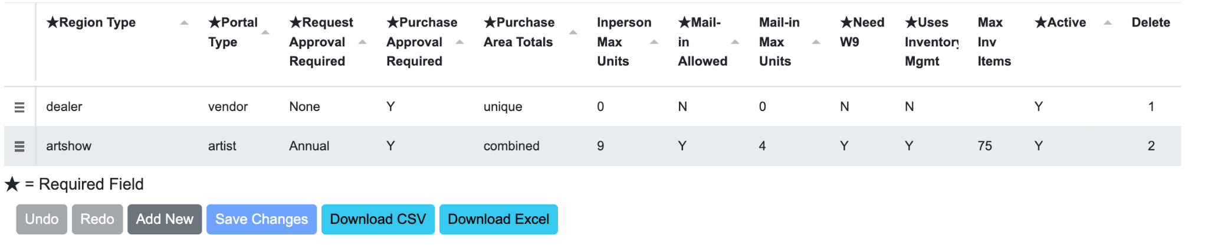

The top level is Region Types, the overall configuration of the rules for each type of Venue (Region) you will be hosting. These rules will be common to every Region of this type.

Exhibitor spaces are sold in increments of units. Think tables, frontage space, etc. Units are numbers with two decimal places, so one half table is easy to specify. For each space you will need to decide on your base unit. The combination of a tri-sided (U shaped) peg board could be one unit, or each side could be one unit.

Then you can decide how you want to sell that space, either as whole or fractional units, or some combination of the two.

#### Configuration Columns

* Region Type: a short name for the region type. It is used in a select list (pull down) on the next screen to select the type of a Region.
* Portal Type: a pull down which specifies which exhibitor portal is used by Regions of this type. An exhibitor portal can display multiple Regions and let the exhibitor request space in any or all of those Regions.
* Request Approval Required: A pull down with three values:
  + None: No advance approval is required to request space in regions of that type
  + Once: An approval is required the first time an exhibitor wants to request space. Once approved, it is remembered for future years and they do not need to request approval again.
  + Annual: An approval is required every year for an exhibitor to request space.

Normally Dealer’s Rooms set this to None (the default value). Art Shows can use this to pre-screen artists before they allow them to request space.

* Purchase Approval Required: A Yes/No pull down.
  + Y: Exhibitors will request space in the Regions of this Region Type. The administrators of that Region will approve, deny, or change the space requested by the exhibitor.
  + N: Any space requested is automatically approved. This is sometimes used by Art Shows that pre-approve artists requesting space. They let the approved artists receive whatever spaces they want to request within the limit sets in the Max Units columns.
* Purchase Area Totals: For Regions made up of multiple Spaces, are the units in each space counted uniquely or combined together for the Max Unit calculations.
  + Unique: Each space can have up to max units requested
  + Combined: The sum of all the units in each space in the region must be less than or equal to the max units.
* In Person Max Units: The number of units an exhibitor who is “In Person” (bringing their exhibit with them and will set it up themselves) may request.
* Mail-in Allowed (Y/N): Are mail-in exhibitors allowed. These are exhibitors which ship their exhibit to the convention and the convention staff sets it up for them.
* Mail-in Max Units: The number of units a mail-in exhibitor may request.
* Need W9 (Y/N): Does this space require an IRS W-9 form so the convention can mail them payments for sales in their space. This generally only applies to Art Show as dealers collect money for their sales themselves.
* Uses Inventory Management (Y/N): Will the exhibitor enter the inventory of their exhibit in advance, using the Exhibitor Portal, for use in the sales and checkout process by the Region. This is most often used by the Art Show. If you run your own inventory management process outside of ConTroll, answer this ‘N’.
* Max Inv Items: How many items (combination of Art, Prints (Not copies of a print) and Not For Sale (Display Only) that an artist can enter into the system.
* Active (Y/N): Is this Type active this year. Used to hide historical types from the next screens selection pulldown.
* Delete: If this column shows a number, this is the number of times this Region is used in the follow on configuration. If a trash can shows, this row can be deleted by clicking on the trash can, because it is not currently in use.

### Regions

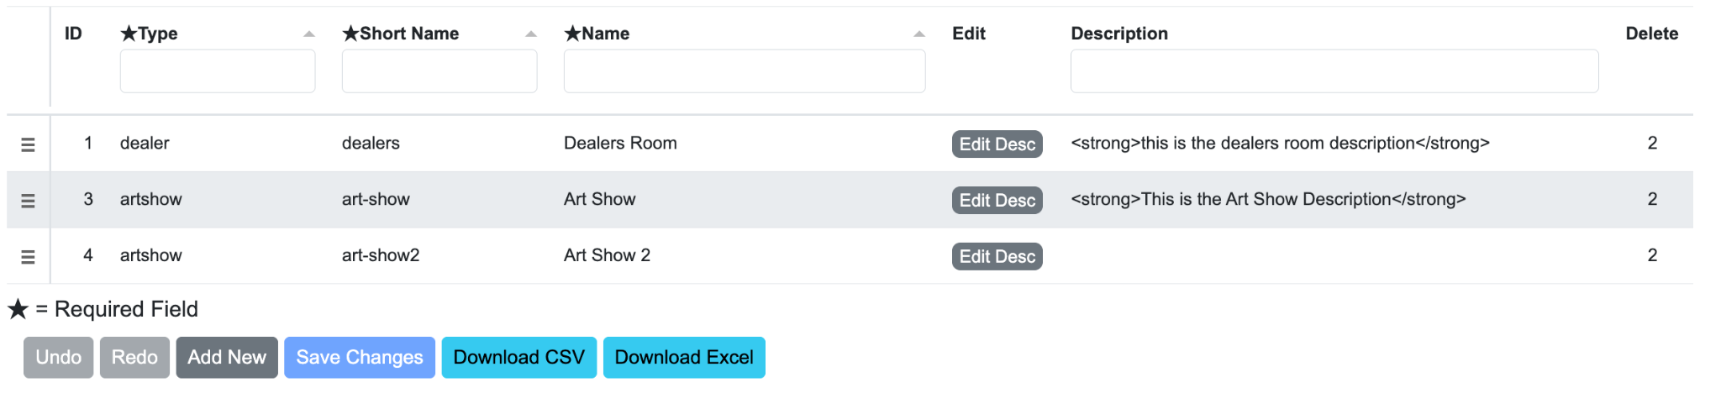

Each exhibition venue is a Region. Each region has a type for its rules. This screen is used to create each region and the information that is persistent from year to year for that Region.

The exhibitor portal will show every Region with that portal type as a separate place they can request space. Each Region is requested separately, approved separately and paid for separately. If a region uses inventory, each Region will also manage its inventory separately.

#### Configuration Columns

* Type: A pull down list of the Region Types which are marked active from the Region Types Tab. This is the set of rules this region will use.
* Short Name: The internal short name used for this Region. It is only shown on the ConTroll screens and not to the exhibitor. (32 characters max)
* Name: The name shown for this region to the Exhibitor. (128 characters max)
* Description: Using the “Edit Description” you can enter basic HTML style text that will be shown in the exhibitor portal to define this Region. An editor pop-up is shown to edit this description. This same style editor popup (tinyMCE) is used for all editing in ConTroll.

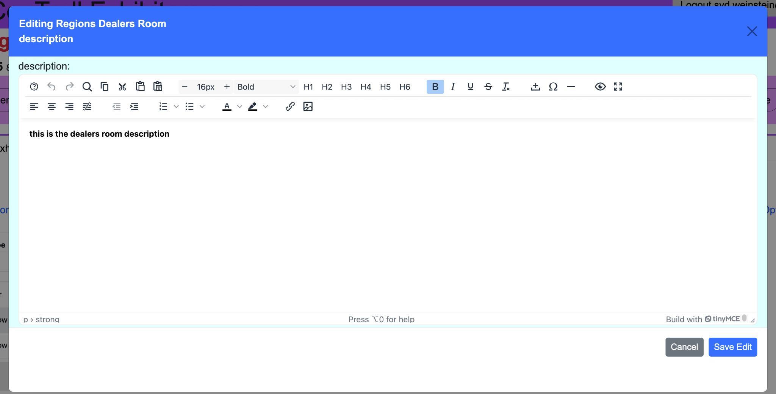

You must use the “Save Edit” button to save the results of this edit back into the table.

* Delete: If this column shows a number, this is the number of times this Region is used in the follow on configuration. If a trash can shows, this row can be deleted by clicking on the trash can, because it is not currently in use.

### Regions for this Year

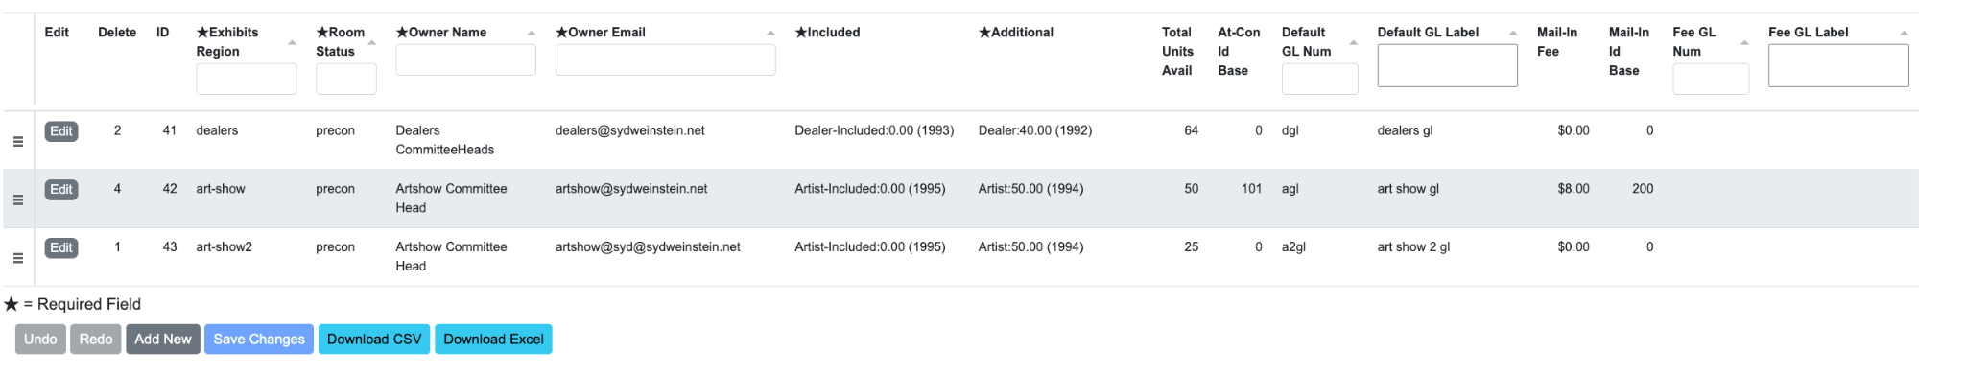

Each year specific data about the Region (Venue) changes. This screen is used to edit/enter this data. On most screens this is wider than the display and has a scroll bar on the bottom of the table to let you move it left/right to see the other columns.

There should only be one row in this table for each Region. But not all Regions need to be active every year.

The Edit button on the left of the line can be used to open a pop-up page to edit the entire row at once rather than scrolling and changing all of the fields. Each of the fields across the row is editable on this screen from top to bottom.

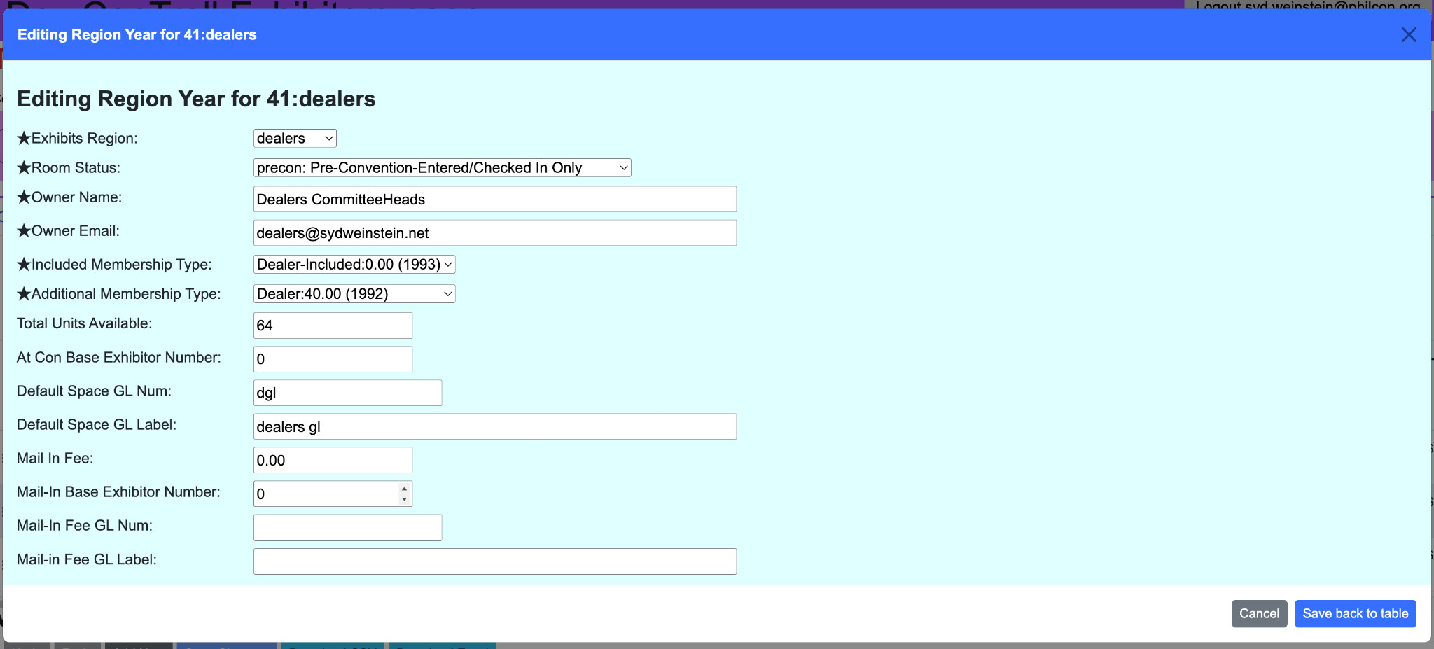

Saving the form back to the table writes the edits back to the table of all of the Regions for this Year. You still have to save the changes on the main screen for the changes to be applied to the database.

#### Configuration Columns

* ID: an internal identifier for display only. It is for internal purposes, but it uniquely defines the region year in receipts and Square Order data.
* Exhibits Region: A pull down of which Region for this row. Any number of spaces can be configured for a region in the Spaces within the Region tab.
* Room Status: The state of the convention for this room. This is only relevant to items that use inventory management and support Art Show Cashier in “atcon”. The status of the room controls what can happen in Art Show Cashier for any art items.
  + precon: before opening, only the statuses of Entered, Not in Show, or Checked in can be made. No art can be sold
  + bid: Items can have their bid price updated. Prints and quicksales can be made.
  + checkout: items can be sold for their final bid value, items can be quick sale items can be released to the purchaser.
  + closed: All items can be sold as per final bid, and the remaining items marked returned to the artist.
  + all: No restriction on what can occur in Art Show Cashier
* Owner Name: The name you want displayed in email signatures, and in other places, as the person, people, or team responsible for this Region. (max 64 characters)
* Owner Email: The email address displayed to the exhibitor for the owner of this region. It is also the address which the system will send transactional messages for approvals.
* Included: A pull down of memberships. These are the memberships assigned to the exhibitor for the “Included Memberships” they register. Included memberships are those which are included in the space purchase as part of the space price. This field is required, even if all of the space prices show 0 as the number of included memberships.
* Additional: A pull down of memberships. These are the memberships assigned to the exhibitor for the “Addiitonal Memberships” they register. Additional memberships are those which are offered at a discounted price as part of the space price. This field is required, even if all of the space prices show 0 as the number of additional memberships.
* Total Units Available: This is for warning if a venue is getting full. It is the total number of units available in the Region.
* At-Con Id Base: If the system is to assign exhibitor numbers to this Region, this is the starting number for at-con (non mail-in) exhibitors. Often the guest of honor spaces are reserved as 100, 101, etc. and this number starts as one higher than the guest of honor numbers. These numbers are assigned in order based on payment date.
* Default GL Num: a string to identify for accounting which General Ledger account receives space purchases for this region. (max 16 characters).
* Default GL Label: a string to identify the name of the General Ledger account. (max 64 characters)
* Mail-in fee: A fee to charge mail-in exhibitors for having the staff set up and return their exhibit.
* Mail-in Id Base: a different number if desired, for mail-in artists to make it easier to tell them apart. Again assigned in payment order.
* Fee GL Num: a string to identify for accounting which General Ledger account receives mail in fees for this region. (max 16 characters).
* Fee GL Label: a string to identify the name of the General Ledger account. (max 64 characters)
* Delete: If this column shows a number, this is the number of times this Region is used in the follow on configuration. If a trash can shows, this row can be deleted by clicking on the trash can, because it is not currently in use.

### Spaces within the Region

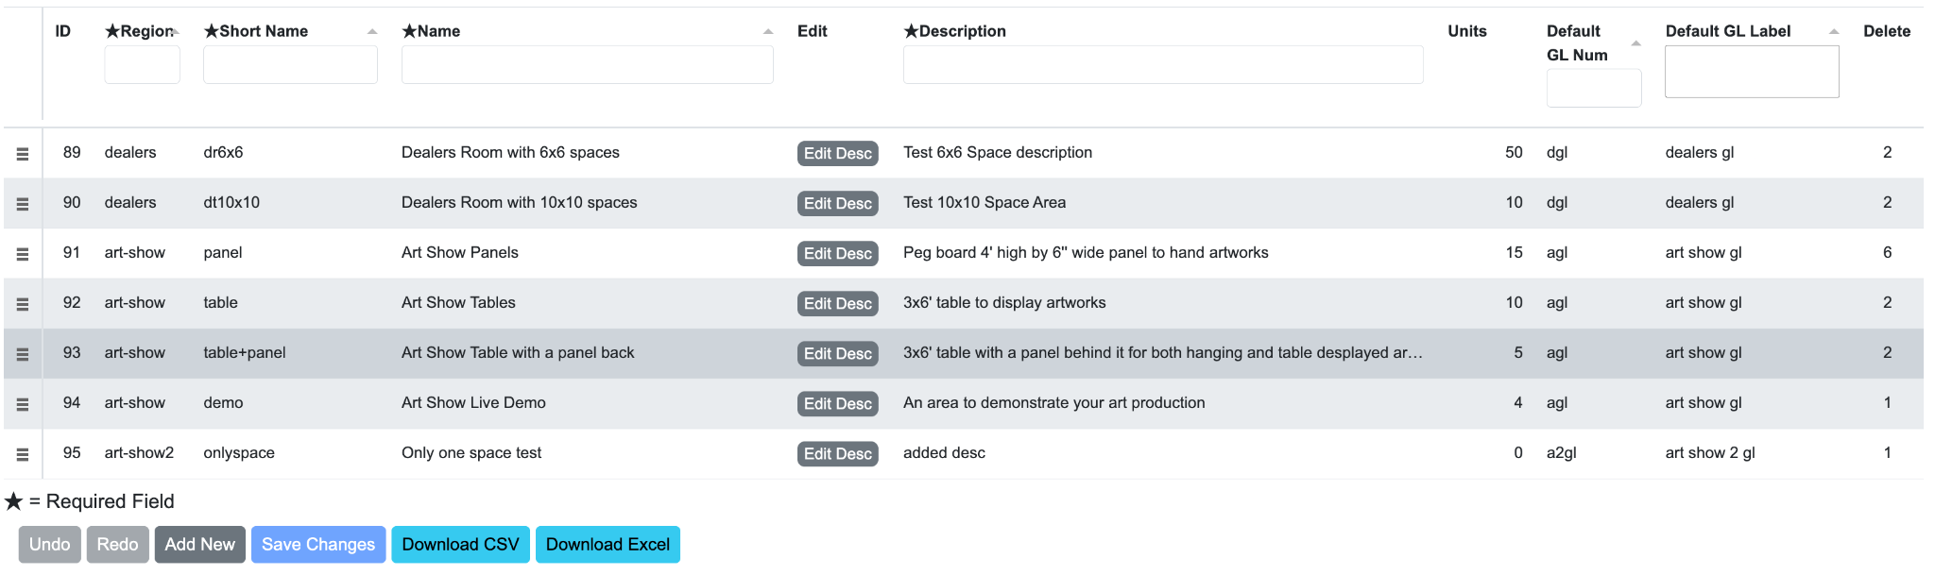

Each Region can have multiple spaces within it. These are basically different types of space offerings. (Tables, Panels, Floor Space, etc.) An exhibitor can make a request in every space for a region. So an exhibitor could, for example, request tables and panels in the Art Show.

#### Configuration Columns

* ID: an internal identifier for display only. It is for internal purposes, but it uniquely defines the space in receipts and Square Order data.
* Exhibits Region: A pull down of which Region for this row. Any number of spaces can be configured for a region.
* Short Name: An shorter name used for display in the ConTroll back end for this Space within the Region (32 characters max)
* Name: The name shown to the exhibitor for this Space within the Region. (max 128 characters)
* Description: Using the “Edit Description” you can enter basic HTML style text that will be shown in the exhibitor portal to define this Space. An editor pop-up is shown to edit this description. This same style editor popup (tinyMCE) is used for all editing in ConTroll.
* Units: The number of units of this Space available in the Region.
* Default GL Num: a string to identify for accounting which General Ledger account receives space purchases for this space. (max 16 characters).
* Default GL Label: a string to identify the name of the General Ledger account. (max 64 characters)
* Delete: If this column shows a number, this is the number of times this Space is used in the follow on configuration. If a trash can shows, this row can be deleted by clicking on the trash can, because it is not currently in use.

### Spaces Pricing Options

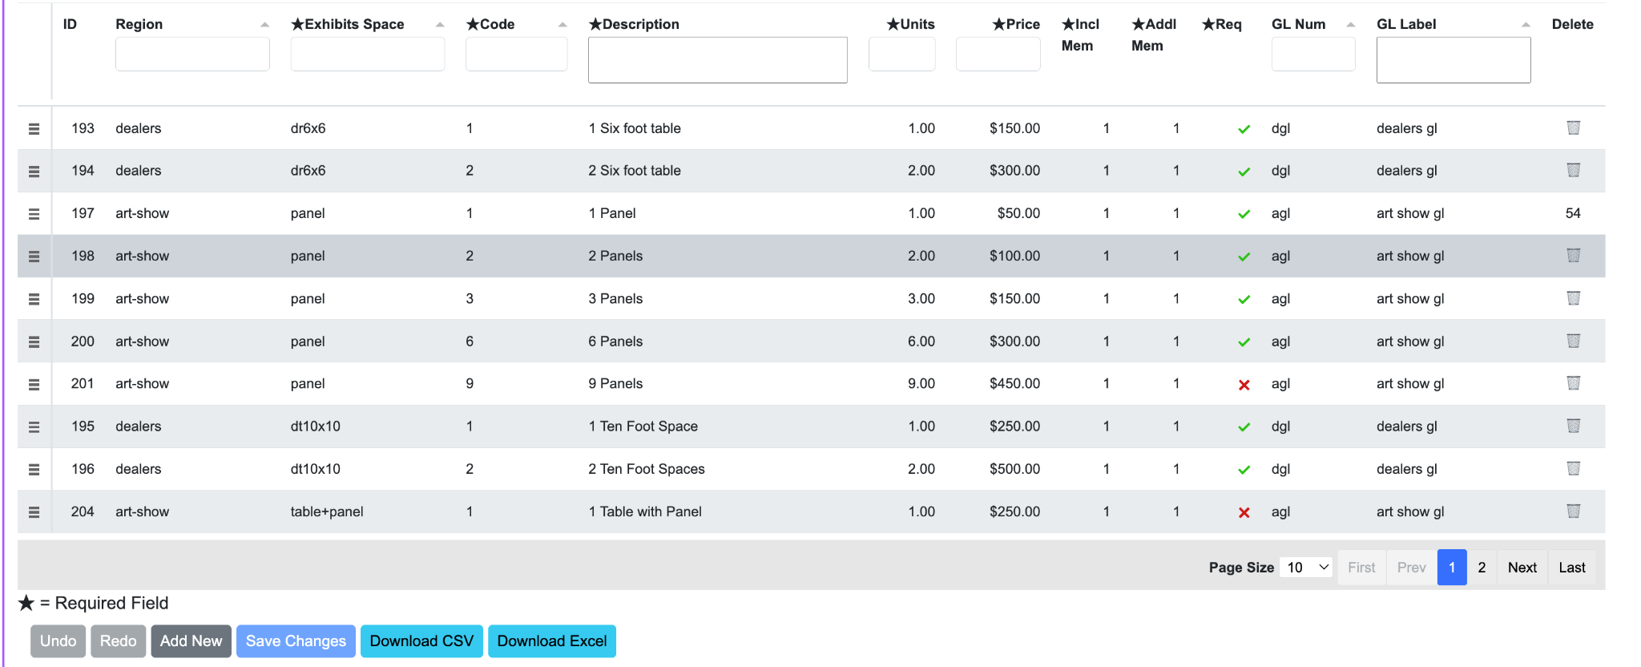

Each space has a set of pricing options. Instead of buying a quantity of each space, the exhibitor is given a pull down of the options available to them. This allows for non-linear pricing. So that multiple quantities of a space could be more or less expensive than then the single quantity times the quantity.

#### Configuration Columns

* ID: an internal identifier for display only. It is for internal purposes, but it uniquely defines the space in receipts and Square Order data.
* Exhibits Region: A display only column driven by the Exhibits Space column, allowing a way to filter by region, as well as by space. It is assigned automatically from the Exhibits Space pulldown.
* Exhibits Space: A pull down of which Space for this row. Changing this changes the Exhibits Region column as necessary.
* Code: A short code used in the ConTroll back end to refer to this space price option. (max 32 characters)
* Description: A relatively short string explaining the option. This string is used in the select list pulldown shown to the exhibitor as well as all references to the space they are requesting or have purchased. (max 64 characters)
* Units: The number of space units consumed by this option, to two decimal places.
* Price: The price of this option including all included memberships
* Incl Mem: The number of memberships included in the price. The membership type is specified in the “Included” column of “Regions for this Year” tab for this region. This can be 0.
* Addl Mem: The number of additional memberships the exhibitor can purchase with this space. The membership type is specified in the “Additional” column of “Regions for this Year” tab for this region. This can be 0.
* Req: Is this space requestable by the Exhibitor, or can it only be assigned to the exhibitor by the Exhibits Administrator. The X means you can assign them the space but they can’t request it, the green check in the same place means they can request it.
* GL Num: a string to identify for accounting which General Ledger account receives space purchases using this space price option. (max 16 characters).
* GL Label: a string to identify the name of the General Ledger account. (max 64 characters)
* Delete: If this column shows a number, this is the number of times this Space Price Option is used by the exhibitors. If a trash can shows, this row can be deleted by clicking on the trash can, because it is not currently in use.

**Note**: While the GL items marked Default are used as defaults for new rows in the subsequent table, the ones in this table are the actual ones used for purchases of spaces. The defaults are used to provide default values for new rows entered in this table.

# 

# Custom Text

The system allows the administrator to create custom text fields within the portals to assist the exhibitor in understanding the conventions specific rules or filling out their information.

This is accessed via the Custom Text tab in the exhibitors page of ConTroll.

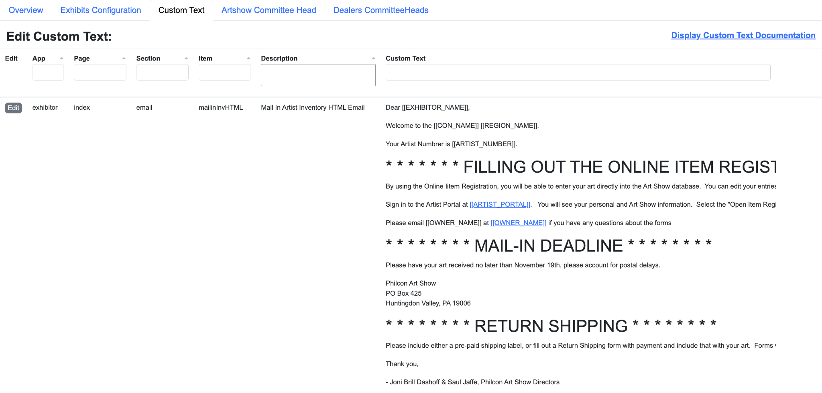

The above is what the page looks like, with a sample entry shown.

Your site administrator can set various options for the custom text displaying in the application. There are three options relevant to the portals:

* all: Display all custom text entries to show you where they will appear in the application. Even the default placeholders are shown.
* production: Display only the non ‘default placeholders’
* none: Suppress all of the custom text fields.

When you are setting up the system, have your administrator set the option to ‘all’ to allow you to see where you can add information to the screens.

### Custom Text Organization

Every piece of custom text has a four part label:

* App: This is the application within ConTroll that uses this custom text. For the exhibitor module this will be ‘exhibitor’ and it is the only app you can edit from the Exhibitors tab.
* Page: This is the web page within your application that the text field will appear. At present the only web page for the portals is index.php, so the only value int he Page field is index.
* Section: This is where in the system this custom text applies. At present the values for exhibitor/index include:
  + email: This custom text is used in email and not on the page itself
  + invoice: The pay invoice modal window
  + login: The login process
  + main: The main page once logged in
  + profile: The edit profile modal window
  + receipt: The display the receipt modal window
  + request: The request space modal window
  + signup: The create a new account modal window
* Item: The location in that Section where the custom text item appears

Each “Default” custom text item includes this four part label in it’s value to help you identify where to find it to edit the contents.

Controll-Default: This is exhibitor-index-invoice-afterPriceArtist

Custom HTML that can replaced with a custom value in the ConTroll Admin App under RegAdmin/Edit Custom Text.

Default text display can be suppressed in the configuration file.

It is shown as app-page-section-item on the first line above.

In the Exhibitor Portals there are often 5 items for any custom text. Using the after price section of the invoice as an example:

* afterPrice: This shows in all of the exhibitor portals and should be used for common text that is independent of being an artist, exhibit hall, fan table or vendor
* afterPriceArtist: This only shows within the artist portal
* afterPriceExhibitor: This only shows within the exhibitor portal
* afterPriceFan: This only shows within the fan table portal
* afterPriceVendor: This only shows within the vendor portal

### Variable Substitution

To make it easier to not have to change the custom text from year to year, it supports two types of variable substitution.

#### Configuration File Variable Substitution

These are entered within # symbols and include both a section and an element separated by a period. For example:

#con.label#

Is replaced by the contents of the label field of the con section of the configuration file, which is the name of the convention, such as “Philcon 2025”.

Using these fields allows you to not have to change the convention year in the custom text for every new convention year. Check with your administrator for what items are in the configuration file and also see the documentation link on the edit custom text page



#### Application Specific Variables

Some sections of the system have specific variables just for that section. Currently only the exhibitor emails support this feature, but it will be extended over time. These variables are contained in double square brackets, such as:

[[EHIBITOR_NAME]]

These usually contain specific values about that specific email.

See the documentation for the current list of variables supported.

#### 

# Exhibitor Portals

Exhibitors will use their own portal to access the system to apply for space, pay for their space and memberships, and add/edit their inventory. All of the portals are basically the same, but react slightly differently based on the rules of the Region.

At present, as there are two exhibitor types supported there are two portals. This will be extended as the others get added.

Artists: https://artist.<your sites base url>

Dealers/Vendors: https://vendor.<your sites base url>

For consistency this documentation will use the Artist Portal because Art Show’s use more of the fields and options normally. But it’s the same underlying system. The document will list which items are hidden or suppressed for vendors vs. artists.

## Login Page

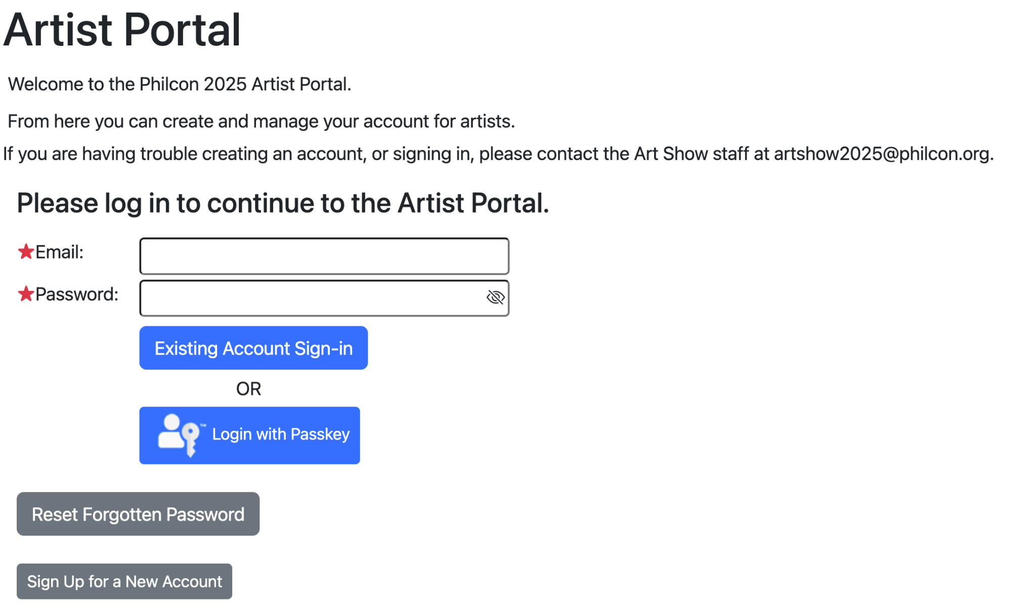

The login page is where all exhibitors arrive on accessing their portal. Of course the word “Artist” is replaced with the word “Vendor” for the vendor portal. The Welcome message auto includes your convention name from the configuration file. The “If you are having trouble…” message is a custom text message configurable in the custom text section of the Exhibitors tab in controll.

Exhibitors log in with their email address and their password they chose at sign up time. If they forgot their password the reset option will email them a temporary password they will need to change when they log in.[1] Note: to avoid spamming an email address, only one password reset email is sent before telling the user to contact the administrator for that portal to reset their password.

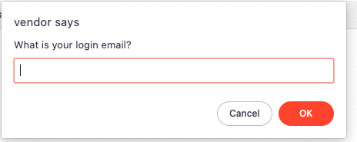

They then return to the portal (does not matter which exhibitor portal they use), use their email address and that temporary password to login and are directed to a change password screen:

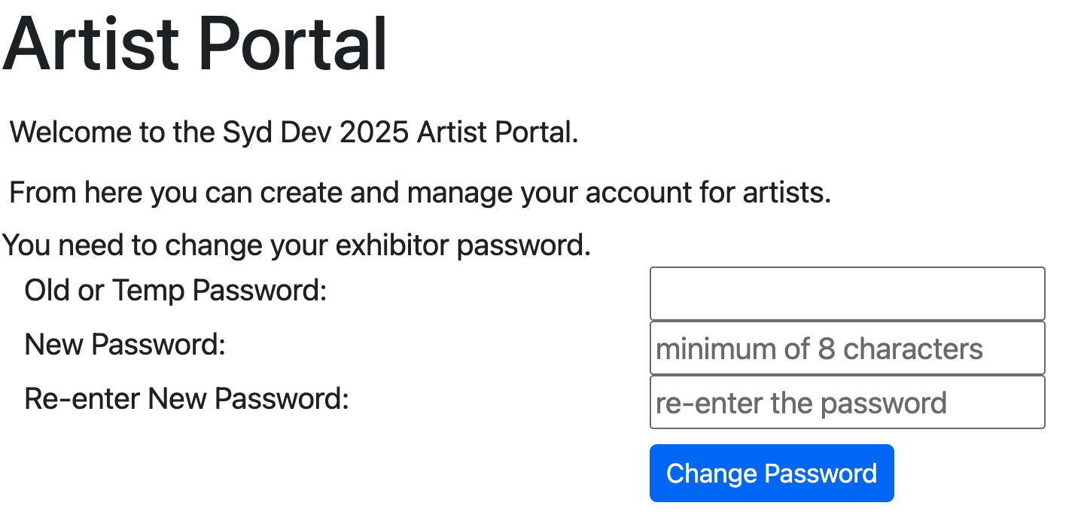

They then need to re-enter that temporary password and their desired new password. After clicking “Change Password” they are logged into the portal.

First time exhibitors need to click on the “Sign Up for a New Account”. Since one account covers all exhibitor types it does not matter which portal they sign up with, but we recommend the Artist portal if they intend to be in the art show as it has the most profile fields.

Creating a new account is presented as a series of four screens. The first screen has a variable number of fields based on the type of the portal.

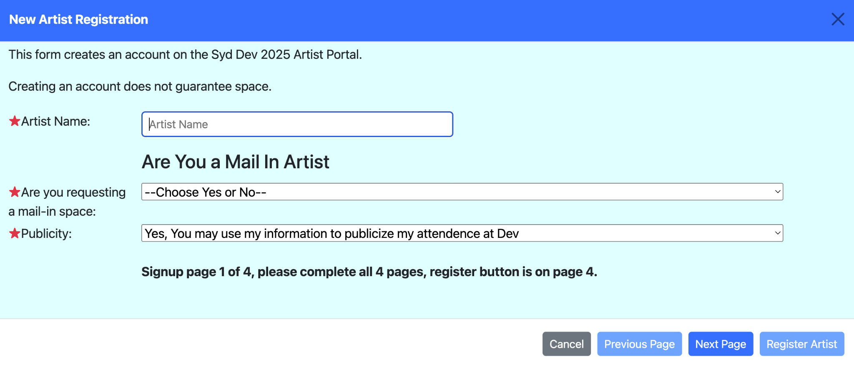

The artist name field is only requested for Artist style portals. They should use the name they want to appear as their artist name and not their business name for this field.

Depending on whether mail-in artists are allowed or not will control the “Are you a Mail In Artist” question.

The publicity question is asked of everyone independent of the type of portal. The “Register” button is only enabled on the last screen of the sequence.

Pressing “Next Page” takes you to the next screen.

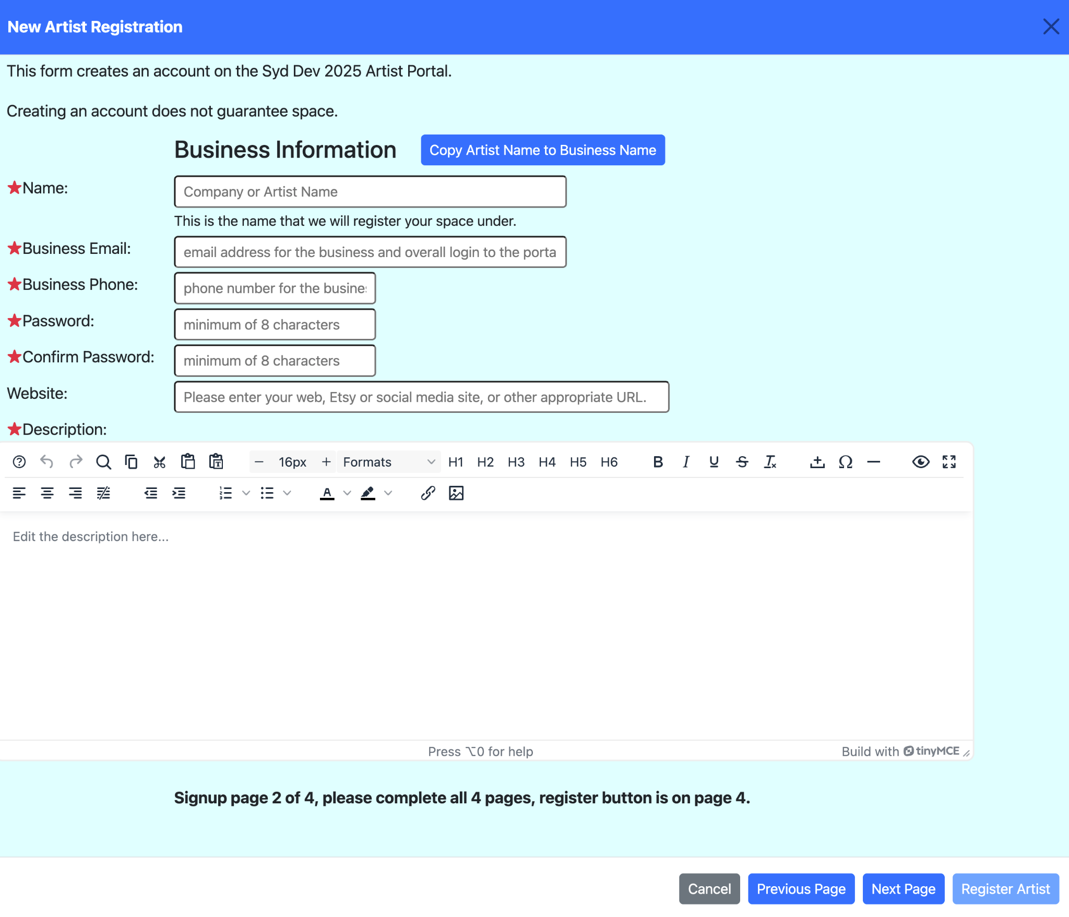

For artist type portals, the copy button appears. It does not appear for other portal types.

This screen is used to enter their business information. The business email and password entered here are their primary login information. Only one exhibitor may register with this email. If it is already in use the system will deny creating the account and request they login with that email address.

Your convention should provide details to the exhibitors as to what they want to appear in the description field. This data will be displayed to you to help in your selection of this exhibitor for space. Use the custom text items under exhibitor-index-signup-pg2* to provide this guidance. (The * is either Artist, Exhibitor, Fan or Vendor).

For the purposes of this documentation, the following was entered for the business information:  
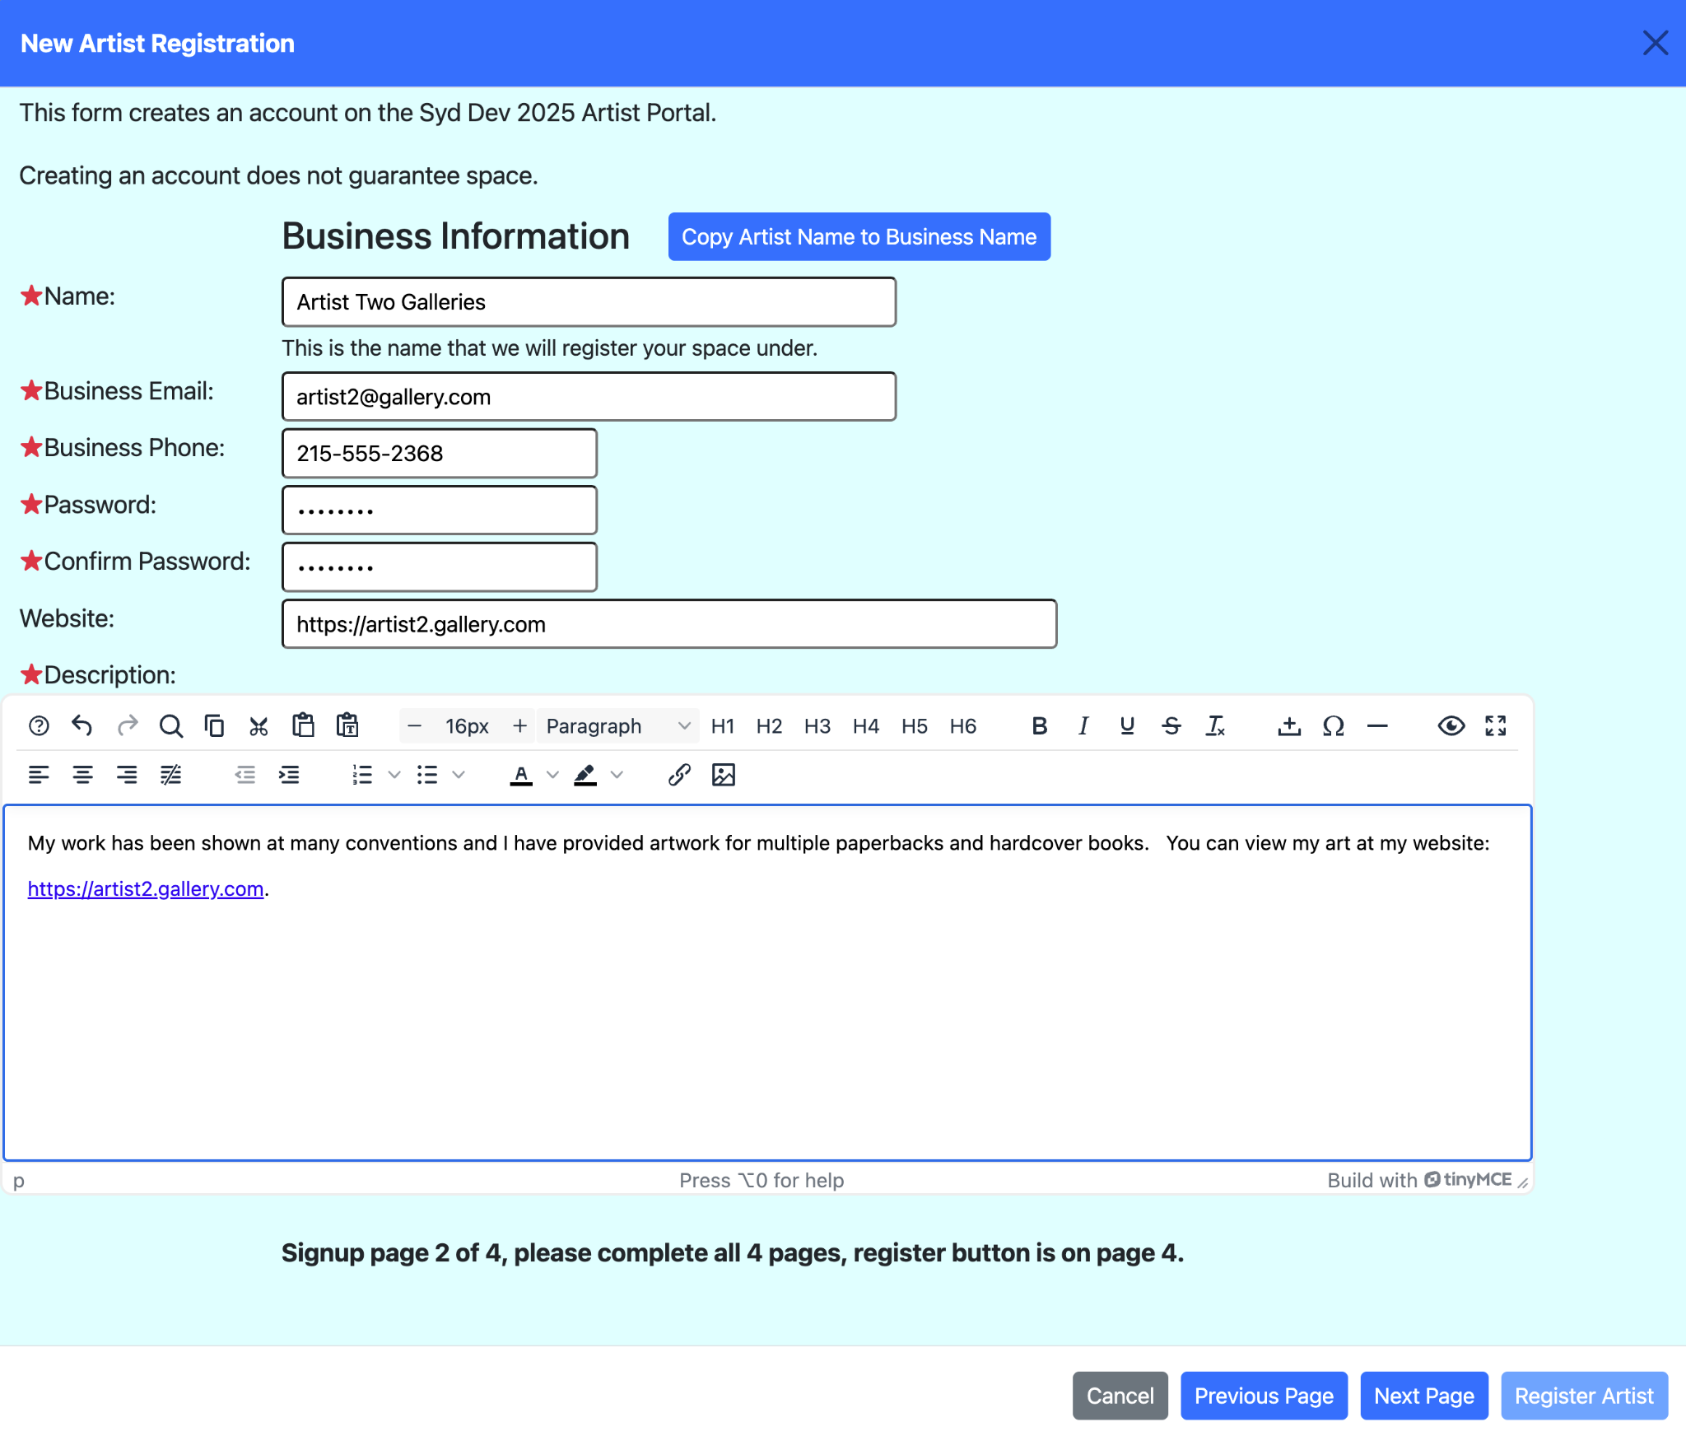

Again pressing “Next Page” takes you to the next screen.

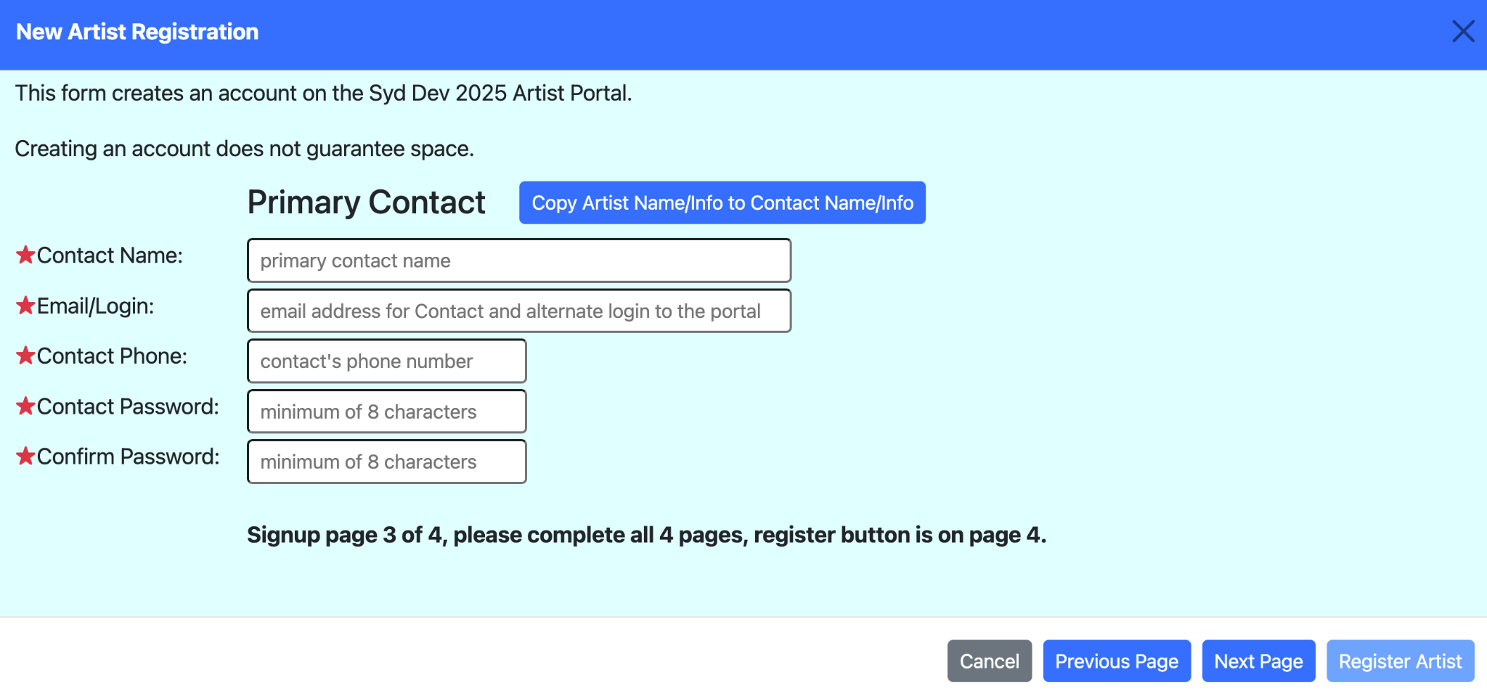

The primary contact is used to indicate the person at the business responsible for this account. The primary contact can be the same as the business information, or it could be a different person who works for them. A primary contact can also log in as the exhibitor. While only one exhibitor can be created per business email address, a primary contact can manage more than one exhibitor. Either email address is valid on the login line, and the password for each exhibitor the contact works with can be the different (uniquely identifying which exhibitor they are logging in as) or the same (providing them a list of exhibitors they can choose between).

If the contact is the same information as the business, just clicking on the “Copy” button will copy the information from the prior page to this page saving having to re-type it.

Again pressing “Next Page” takes you to the next screen.

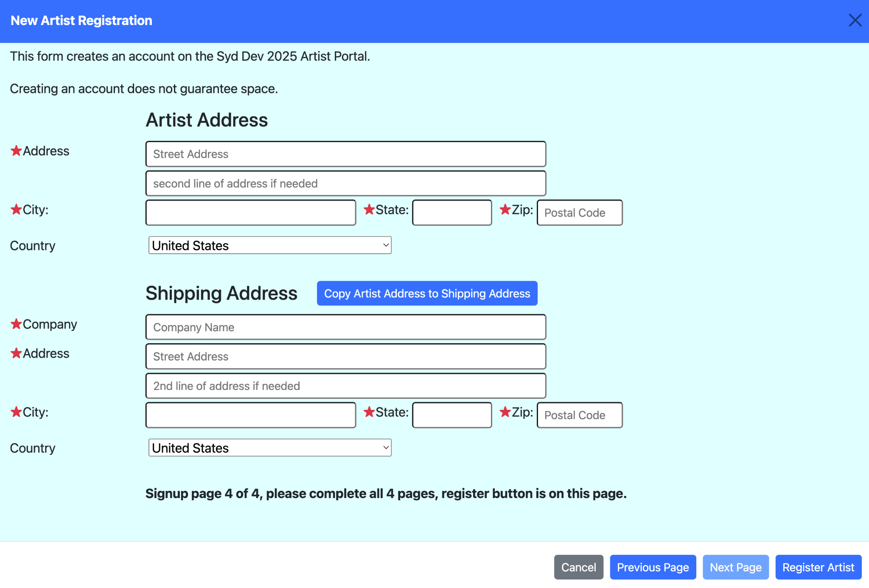

For mail in exhibitors, the return shipping address fields appear. They are suppressed for others. The “Copy” button will copy the address to the shipping address saving retyping if they are the same.

Clicking “Register Artist” will create the account and take them back to the login screen to login to the account.

### Logging in to the Account:

The first time you log into the account for a new convention year will display a popup to review and/or correct the data you have entered. It is a single screen which is a combination of the four screens you used to create the account:

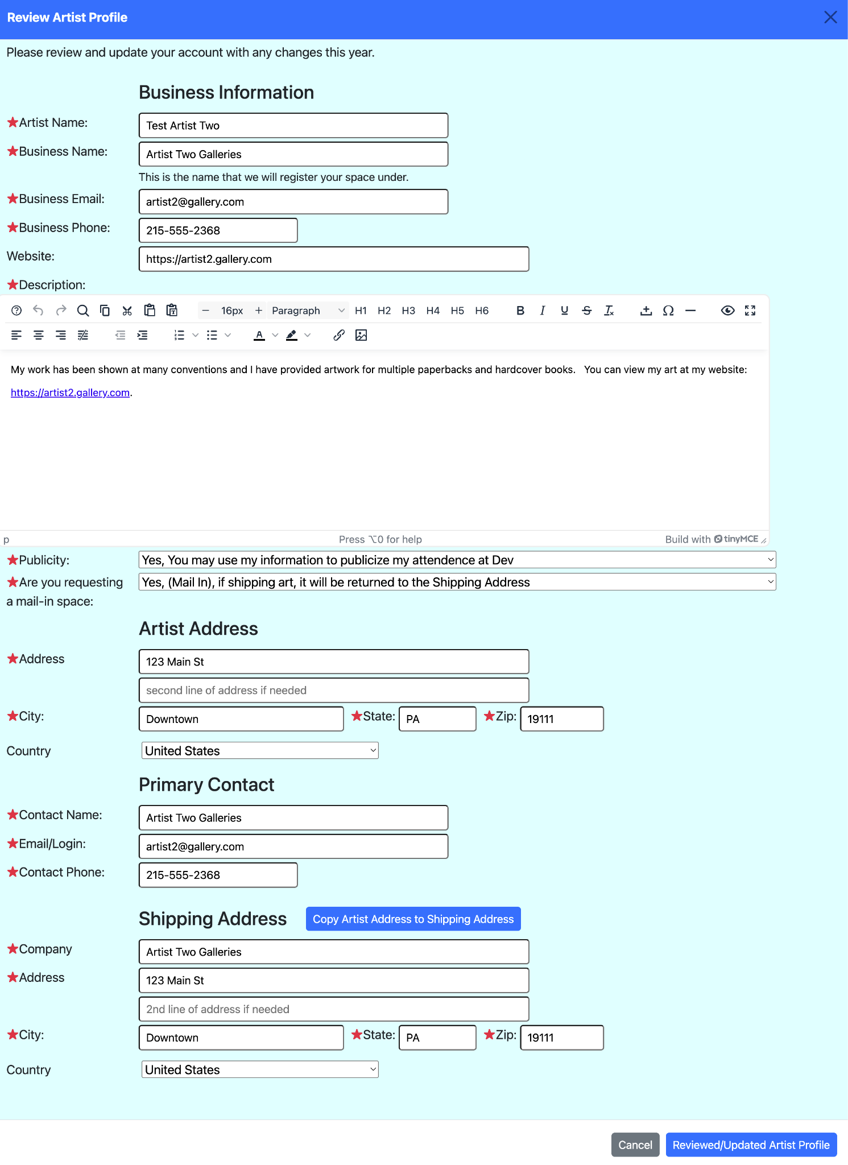

Again the artist name will only appear in the Artist portal. The mail in question and shipping address will only appear if Mail in is allowed.

Review and correct any data that needs changing and click the “Reviewed/Updated” button to proceed to the portal.

## Portal Home Page

The portal home page varies based on what you have done before for each Region (Venue) for which you can request space. The demo system has the following areas for Artists:

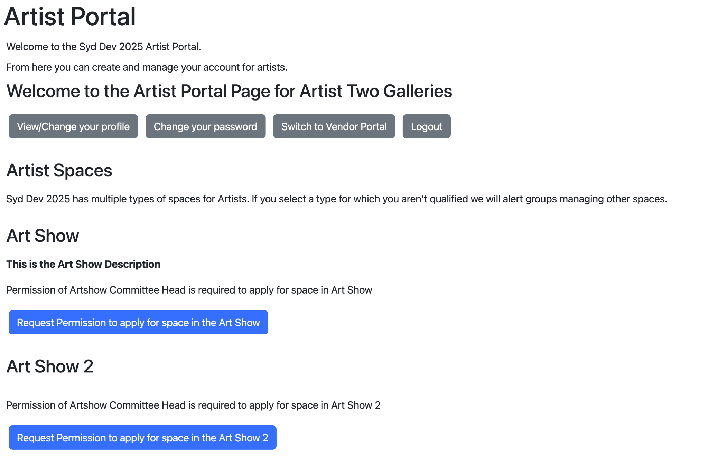

The top area are action buttons you can use which are gray because they are not the primary actions (which throughout the system are in the dark blue). These are:

* View/Change your profile: Open a pop-up to edit the profile data you entered. This is exactly the same screen you saw above for reviewing your data on the first login.
* Change your password: This opens a screen asking for your existing and new password.

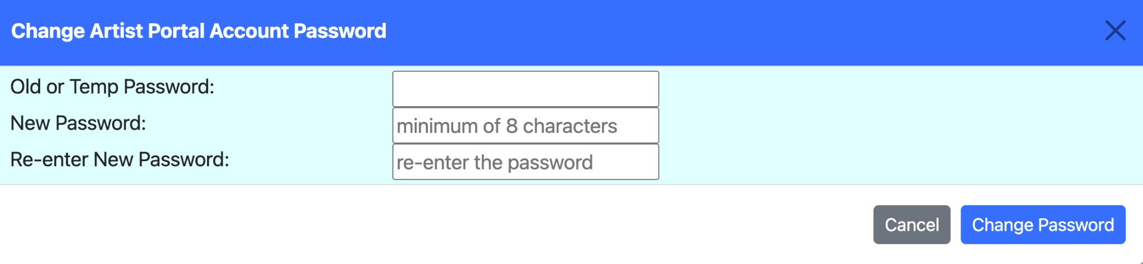

Changing your password does not make you log back in.

* Switch to “XXX” Portal: Since one account is for all portal types, this allows you to change the type of portal without having to log out and back in again in the other portal.
* Logout: Ends your session and returns you to the login screen.

The remainder of the screen describes the spaces available to you and a prompt based on the stage of the sign up process you are in for each space:

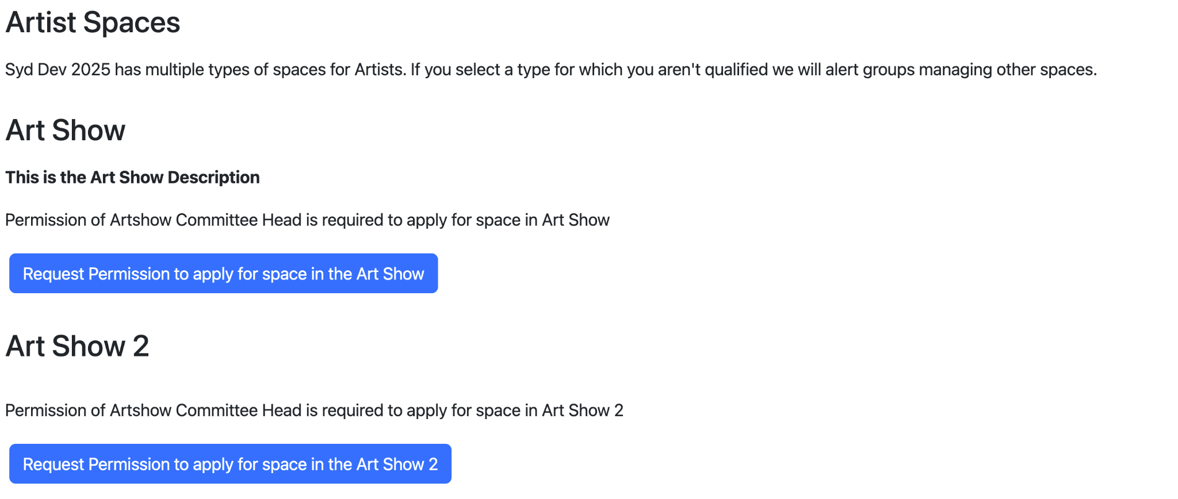

This example has two spaces. So the top section just tells you that there are multiple spaces available to you. If only one space is available this section is not shown.

For each of the spaces you are presented with the name of the space, the contents of the description for the space, a status area, if appropriate and a button to proceed with the next step for that space.

In this case both art shows require requesting permission to apply for space. Clicking on the button will send a request to the owners of that space asking for permission to apply.

If you refresh the page you will see that you have requested the space.

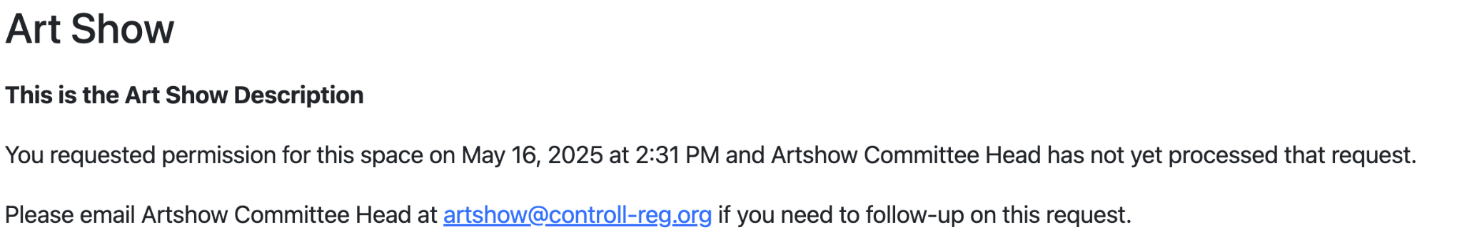

You will receive a copy of the email sent to the owners showing you that the request was sent.

Once your request has been approved (or denied) you will receive an email with their decision. If approved logging back in will show you the next step in the process of requesting space:

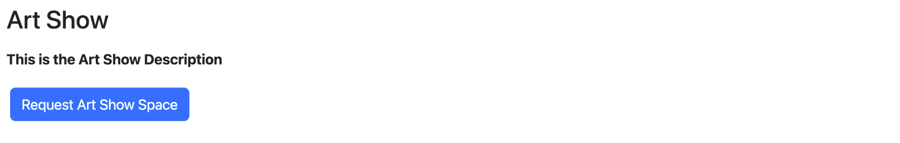

(For brevity the rest of the screen is not shown, and has not changed).

Pressing the “Request Art Show Space” button will provide a pop-up for you to request the space you want in the exhibit.

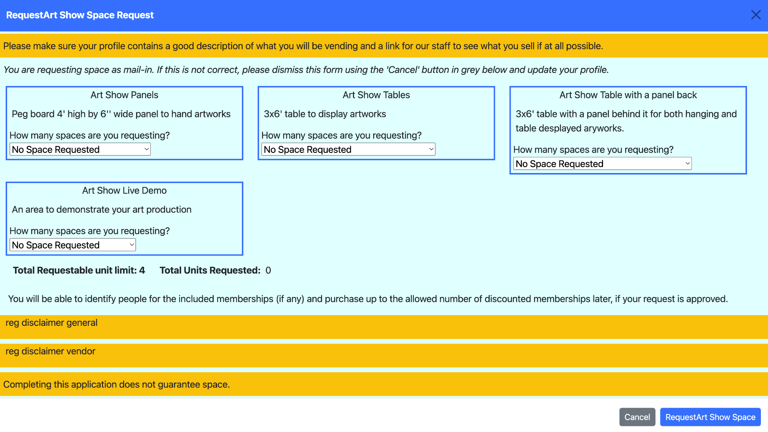

In this example, there are four types of spaces you can request. These are shown as the four blocks on the screen. You do not have to request space in all four, any combination is allowed.

At the bottom of the page are three disclaimers.[2] As an exhibitor read the disclaimers to understand the rules and limitations of the space being requested.

Each space block has a pull down list of all possible “requestable” items for this space type.[3]

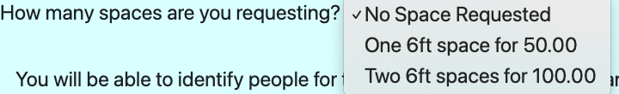

You may select any quantity of spaces of this type listed, including “No Space Requested” to indicate you do not wish to purchase any of this type.[4]

Once you have chosen your space requests press the “Request Space” button. Both the coordinator of the space and you will receive a confirmation email confirming your request.[5]

The portal will update to show:

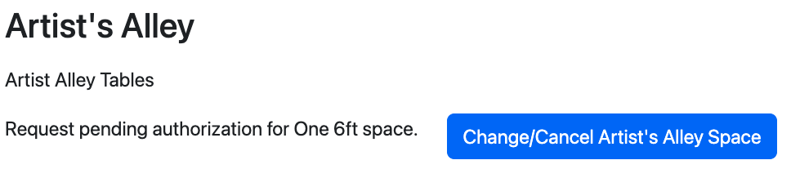

### Changing/Canceling a space request

Pressing the “Change/Cancel Space” button will show a similar popup as request did, allowing you to change or cancel your space request.

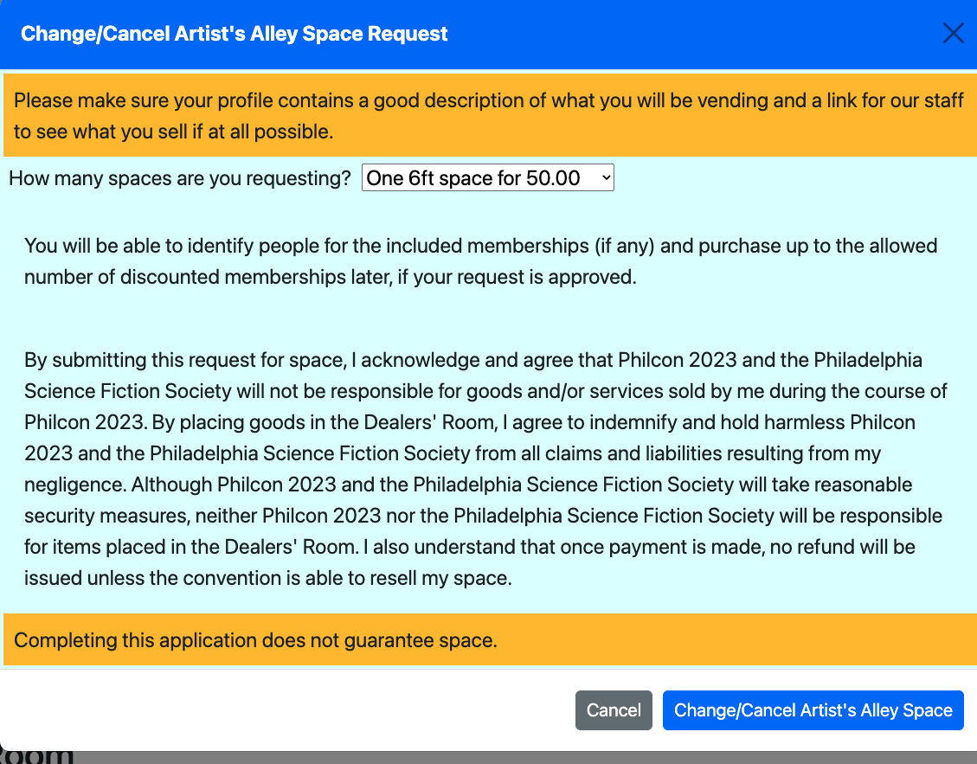

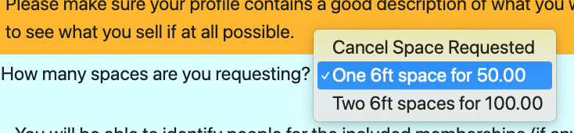

This screen is identical to the request space screen, except it says “Cancel Space Requested” vs “No Space Requested” as the top option of the pulldown list.

When you press the “Change/Cancel Space” button it will send both you and the coordinator of this space a confirmation email.

The portal updates to show that your request is pending. The portal will continue to show this pending message until the space is approved, modified or denied by the space coordinator.[6]

### Paying for an approved space request

When the space request is approved by the coordinator you will receive an approval email asking you to sign into the portal and pay the invoice. When you next access the portal, that region will display the “Pay Invoice” button: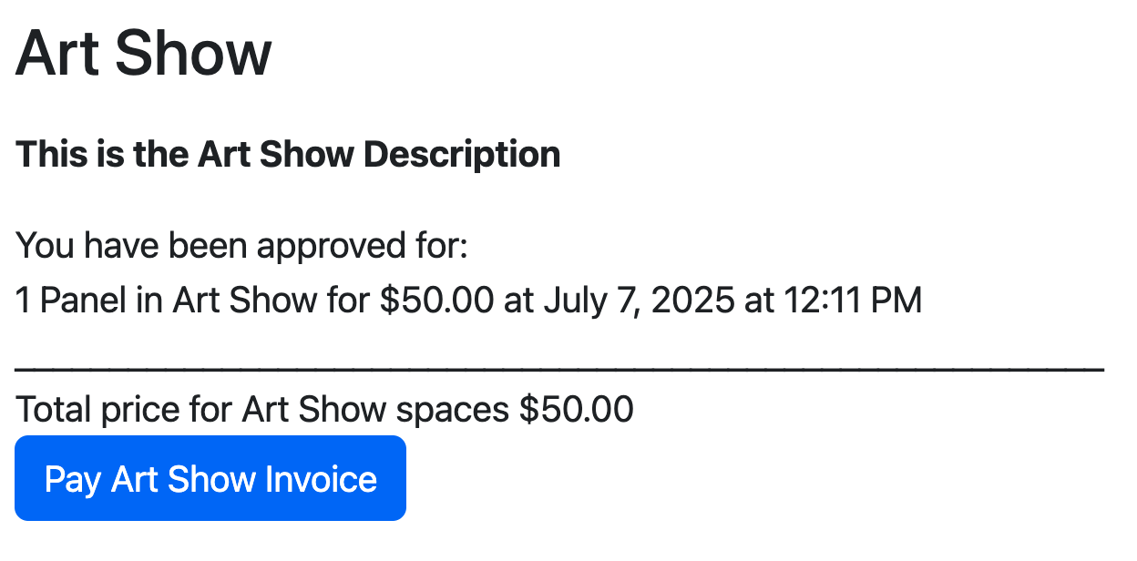

Pressing the button brings up the payment popup. This popup is very large and has up to 5 sections in it:

#### Sections 1 and 2: Confirmation

Confirmation of the space being paid for and confirming that the exhibitor information is still correct. It also allows for updating your exhibitor information.

If the checkbox about purchasing memberships is not checked acknowledging that they must be purchased at this time to get a discount, the system will require you to enter at least one membership.

If you are a vendor, there is a field to enter your sales tax id. [7]The prompt for the sales tax id comes from the configuration file. If the prompt is the empty string, the field is suppressed.

The total space cost is the cost of the space from the space configuration. Since included memberships (if any) are part of this price they will not effect the total price at the bottom of the form. It does not include additional memberships and those will appear at the bottom of the form.

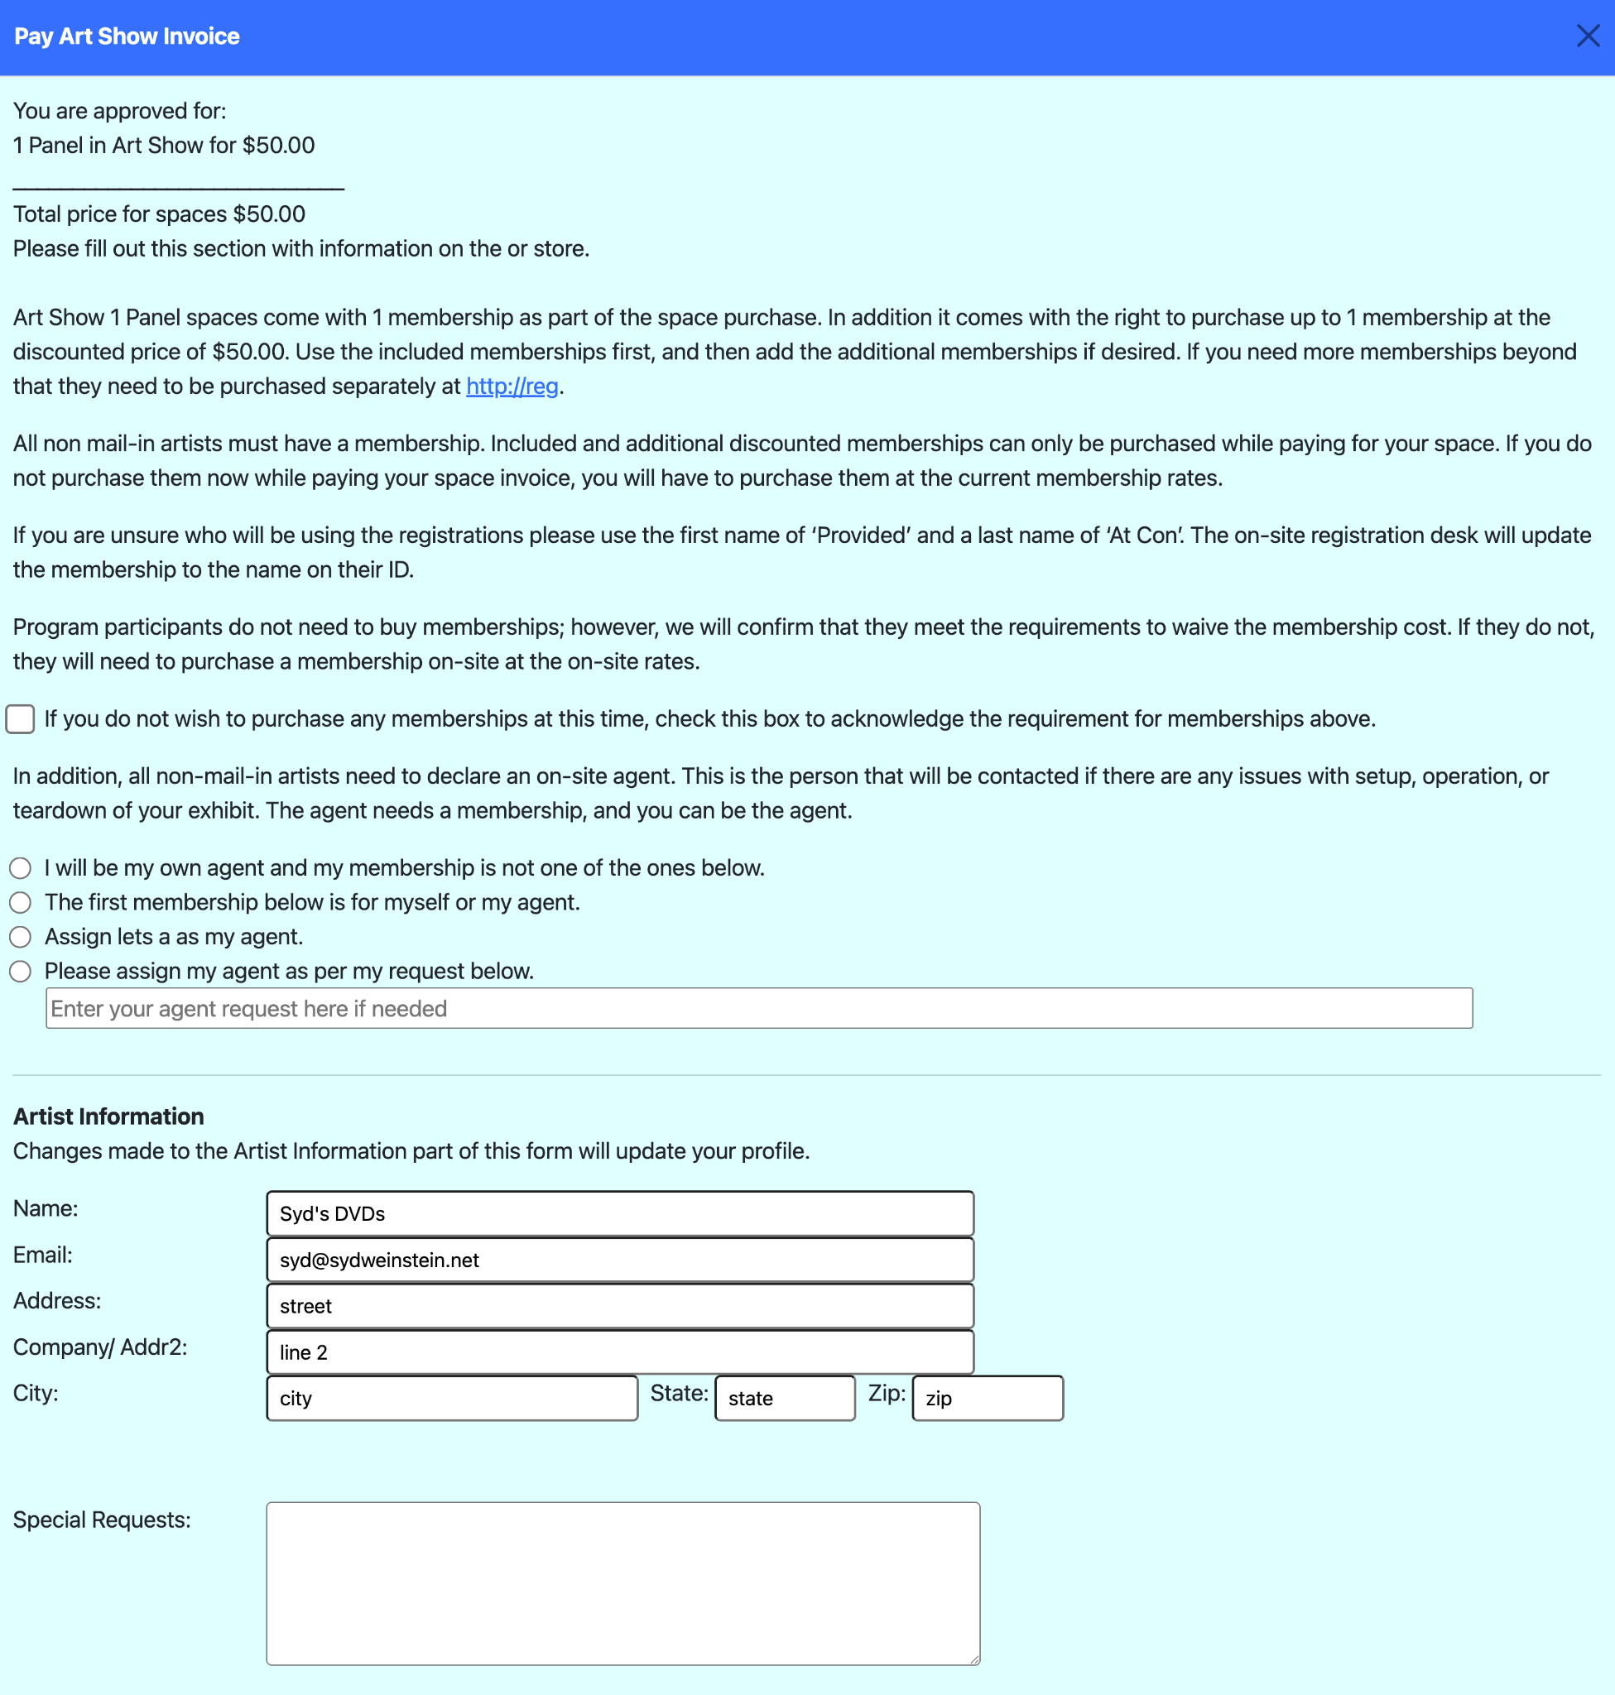

#### Section 3: Included Memberships

If the space you purchased comes with included memberships, this section will list the number of included memberships and provide a block to enter each included membership.

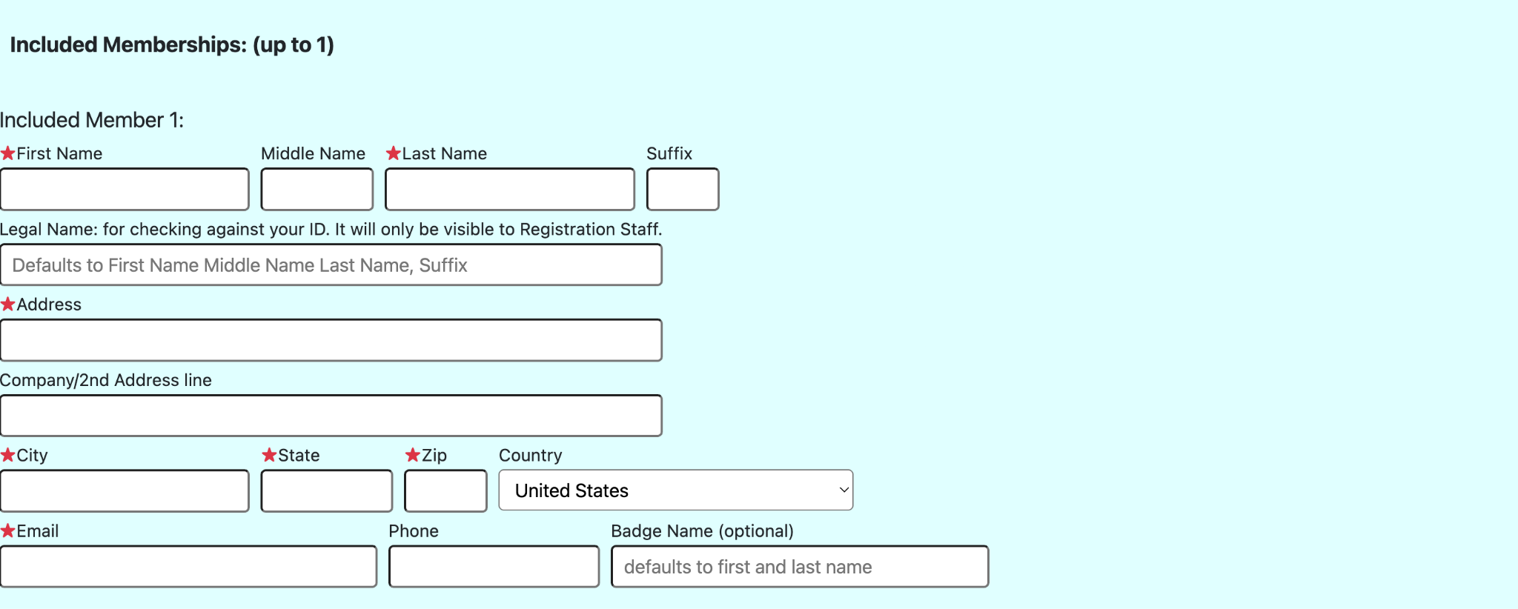

If any field is entered in the membership sub blocks, the required fields (indicated by the red stars) are enforced. If you enter nothing in that entire section for that membership, that included membership is ‘declined’ and not entered. The system will require that you use all included memberships before using the additional ones.

#### Section 4: Additional Memberships

If the space you purchased comes with the option to purchase additional memberships at a discount, this section will list the number of additional memberships and provide a block to enter each additional membership.

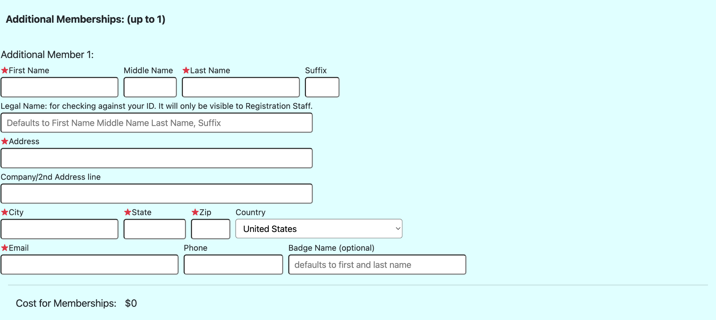

Again, if any field is entered in a membership sub block, the required fields are enforced. If they sub block is entirely blank, the additional membership is ‘declined’ and not entered. The system will require that included memberships be used before the additional ones.

At the bottom of this section is the cost for the additional memberships and it will update as you enter additional membership.

#### Section 5: Total Cost and Payment:

The screen grap continues from the cost for additional memberships to the bottom of the form.

It shows the additional costs for memberships, if any, and the total cost. It also solicits the payment information. It pre-populates the address and email, but you can override them here to match the credit card information.[8]

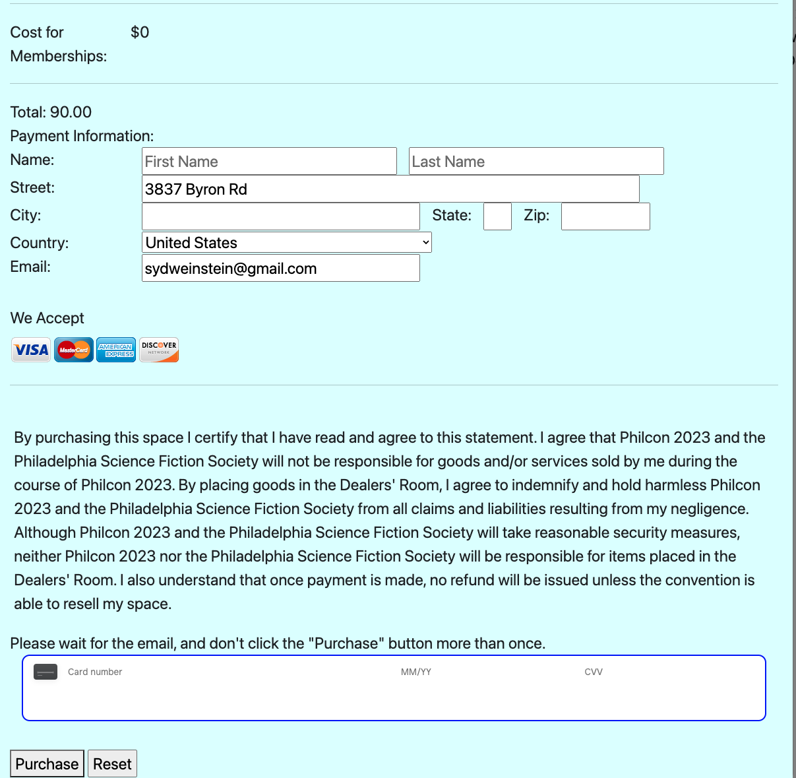

On a successful purchase a confirmation email is sent to you and the coordinator of the space.

### Paid confirmed spaces

Once the space has been paid for the portal changes to show the full registered spaces:

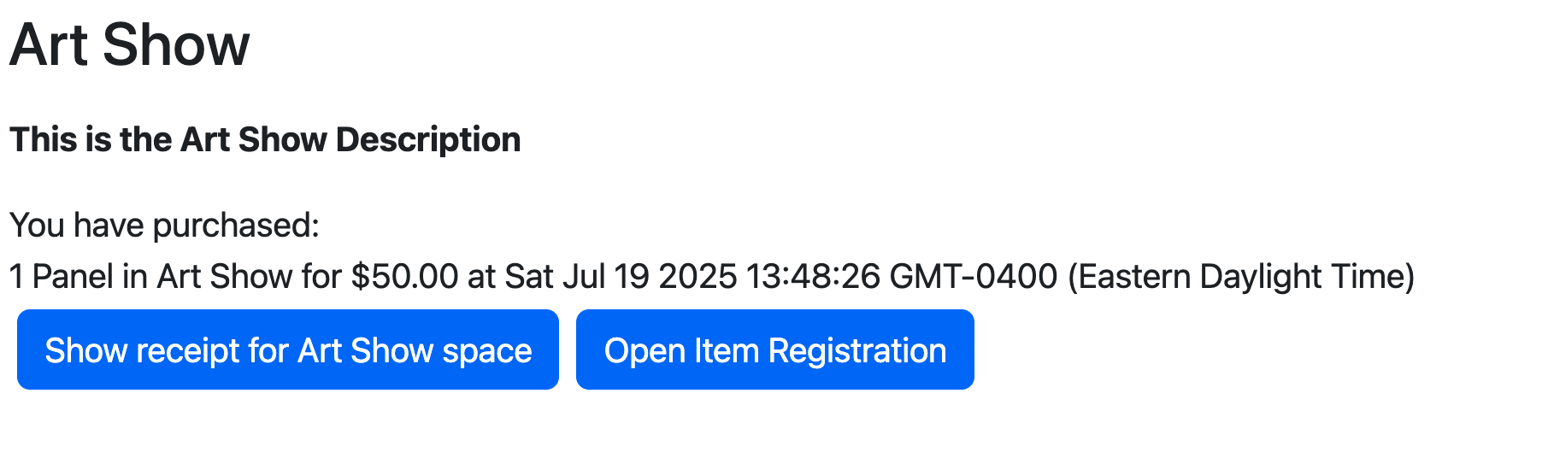

The “Show receipt” button will open a pop-up with your payment receipt:

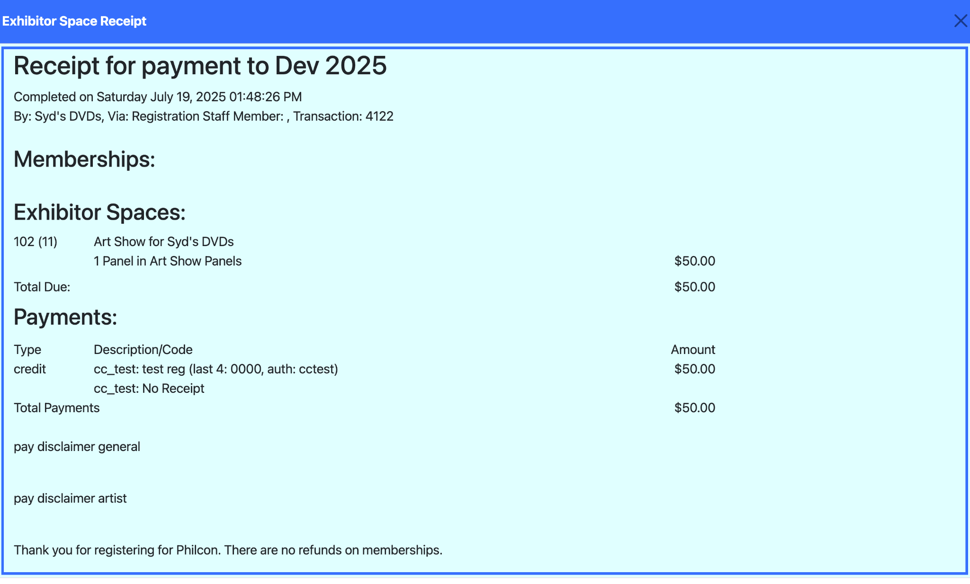

At the bottom of this page is a button to email yourself a copy of the receipt.[9]

### Item Registration

Artists or any exhibitor using a region that requires inventory management will need to register the items they are bringing. Each venue sets a limit on the number of items you can bring.

Items are broken into three groups:

* Art Items: Items being brought for sale, either via Quicksale, a silent auction, or a voice auction.
* Prints: Copies of an object, where multiple copies are brought and the items are available for direct sale. A set of copies of a print count as one item.
* Display Only (Not for Sale): Items you will be showing, but are not for sale and only to display your work.

The names displayed for each of these three groups may vary based on the venue, but the meaning is the same.

#### Art Items

The first section of the screen is the art items section. As with all sections there is a set of four buttons on the bottom.

* Undo: undo the last change
* Redo: redo the last undone change
* Add New: Add a new item to the bottom of the table
* Save Changes: save your changes back to the system. The changes are temporary on the screen until saved. The button will enable and say “Save Changes*” when there are unsaved changes. Each section’s button only saves the changes for that section. It is recommended that you save often so you do not lose your entries if something happens.

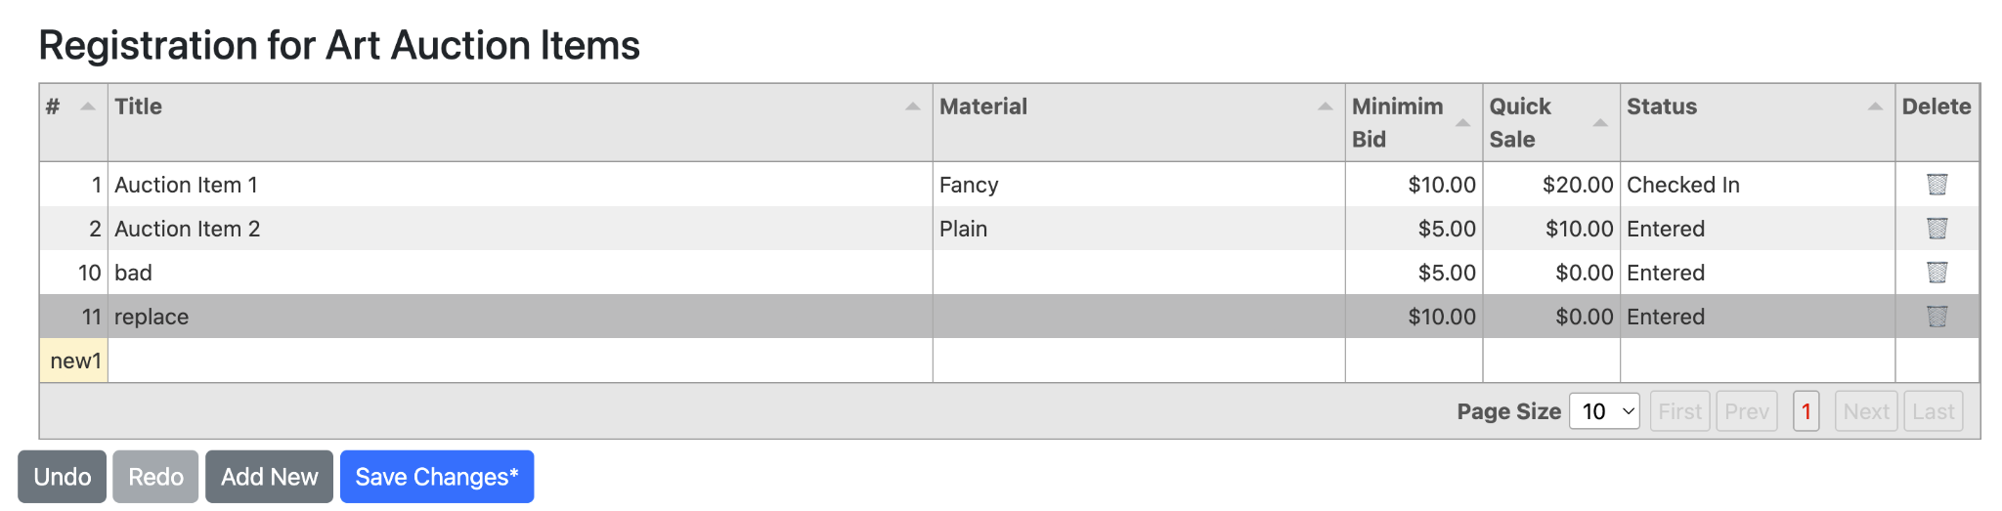

The fields for art items are:

* #, or “Piece #”: This is a number that will uniquely identify your inventory entry. It is assigned by the system starting with one. New rows until saved are “new1”, “new2”,... and will change to the assigned number on save.
* Title: your title for the work, up to 64 characters. Shorter is always better.
* Material: This field is optional and displays on the bid sheet. It is limited to 32 characters.
* Minimum Bid: This is a required field and is the starting bid. Traditionally bids are in even dollar amounts.
* Quick Sale: Selling an item via quick sale is optional. If no one has yet bid on an item, a buyer can buy it without auction as a “Quick Sale.” If this field is blank or $0.00 the item is not available for quick sale and only can be purchased via bids. The quick sale price must be greater than the minimum bid.
* Status: This is a display only field. It is controlled by the system. When you enter items the status becomes “Entered”. As the venue processes your items this field will change. You can only edit items that are in the blank (new) or ‘Entered’ status. Once the venue has taken control all changes must be made by the coordinator.
* Delete: If this shows a trash can, you can delete this row and remove it from the inventory.

To change a field, just put your cursor over a field and click on it, or use the tab key to move left to right on a row. Unsaved changed fields are shown with a tan background color. Don’t forget to save your changes or these will be lost.

#### Print Items

Each set of prints is a print item.

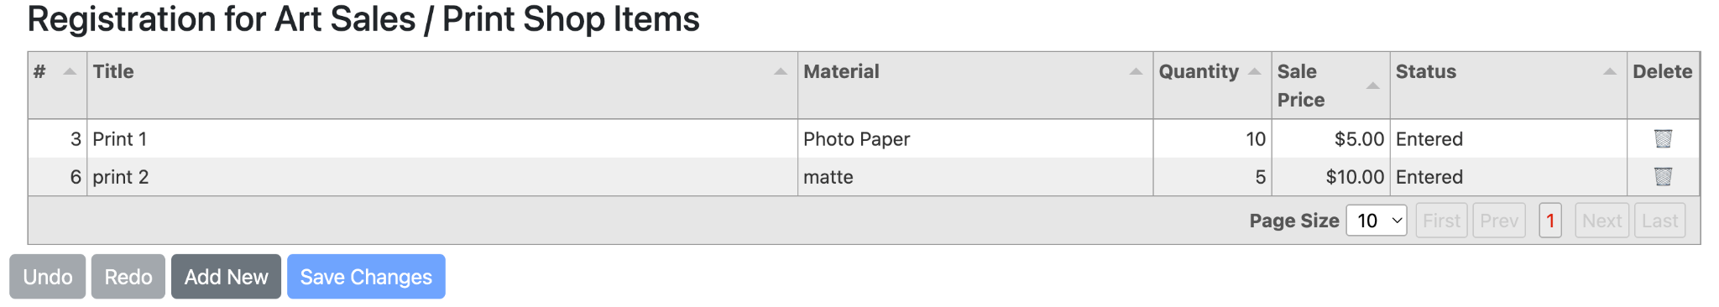

Again, the buttons have the same meaning in all sections. The fields are:

* #, or “Piece #”: This is a number that will uniquely identify your inventory entry. It is assigned by the system starting with one. New rows until saved are “new1”, “new2”,... and will change to the assigned number on save. Note: numbers continue across all sections.
* Title: your title for the work, up to 64 characters. Shorter is always better.
* Material: This field is optional and displays on the bid sheet. It is limited to 32 characters.
* Quantity: How many copies of this print item are you bringing.
* Sale Price: Prints sell by direct sale. This is the price for each copy of the print, usually expressed in even dollar amounts.
* Status: This is a display only field. It is controlled by the system. When you enter items the status becomes “Entered”. As the venue processes your items this field will change. You can only edit items that are in the blank (new) or ‘Entered’ status. Once the venue has taken control all changes must be made by the coordinator.
* Delete: If this shows a trash can, you can delete this row and remove it from the inventory.

#### Display Only / Not For Sale Items

Each item being displayed needs it’s own inventory entry.

#### 

Again, the buttons have the same meaning in all sections. The fields are:

* #, or “Piece #”: This is a number that will uniquely identify your inventory entry. It is assigned by the system starting with one. New rows until saved are “new1”, “new2”,... and will change to the assigned number on save. Note: numbers continue across all sections.
* Title: your title for the work, up to 64 characters. Shorter is always better.
* Material: This field is optional and displays on the bid sheet. It is limited to 32 characters.
* Insurance Price: If the venue insures your art, this is the value to insure. If they do not, this is the value for your own insurance (if any).
* Status: This is a display only field. It is controlled by the system. When you enter items the status becomes “Entered”. As the venue processes your items this field will change. You can only edit items that are in the blank (new) or ‘Entered’ status. Once the venue has taken control all changes must be made by the coordinator.
* Delete: If this shows a trash can, you can delete this row and remove it from the inventory.

#### Bottom Action Buttons

At the bottom of the pop-up are three action buttons and the button to close the popup.



The venue uses bidsheets for all art items and display items. Prints use a sales tag for each copy of the print. These should be attached to each art item and will be placed near or below the item being sold. They display in a new browser tab/window and can be printed from the browser.

The venue uses “Control Sheet”s to record which items are entered by each artist, and the final price and disposition of each item. You should bring your “Entry” control sheet with you (or include it in your shipment. The venue will print “checked in” control sheets for what is actually displayed, and copies of the release control sheets. Usually one for you to sign and they will keep, and one for you to keep.

#### Sample Control Sheet

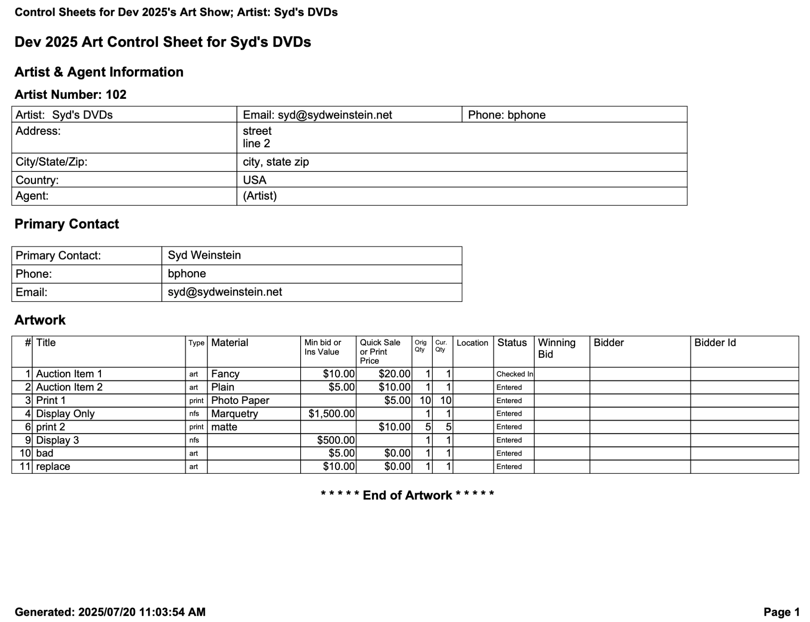

# Exhibitor Management in ConTroll

Each region has its own tab within the Exhibitor page in ConTroll:



They are organized by the Owner Name on the top line and the Exhibits Region on the second line.

The screen displayed is broken into two portions. On top is a quick reminder of the space allocations.

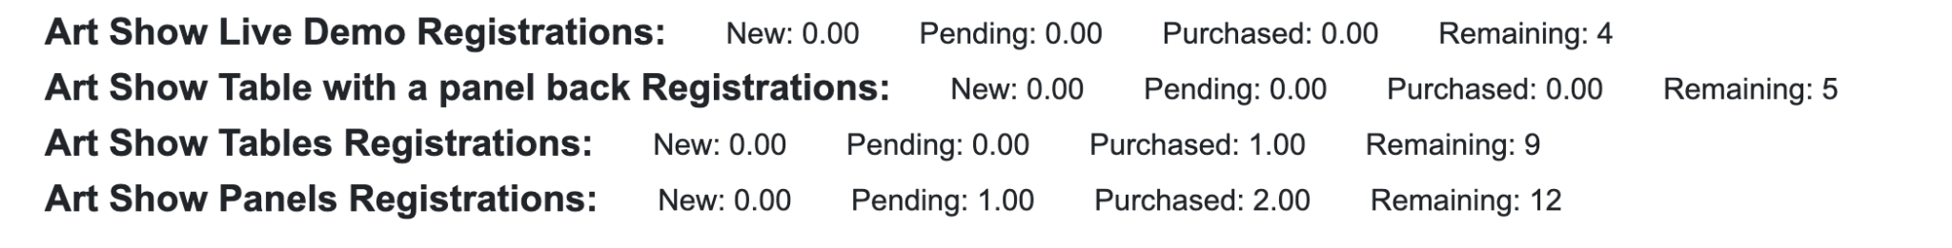

For each Space it provides up to date statistics in units.

* New: New requests not yet approved/modified/denied
* Pending: Requests that have been approved/modified and are pending payment
* Purchased: Amount of units paid for
* Remaining: Total Units available minus the sum of the pending and purchased.

The remaining space is divided into three tabs.



* Space Requests: The status and actions available on all space request in this Region
* Approval Requests: If you have configured the system to require approval to request space, this tab lists the status and action of all of those requests. If you are not using approve to request space as an option, this tab does not appear
* Exhibitors Information: This tab shows all exhibitors in the system, independent of the portal to which they used. It allows importing past exhibitors, adding new ones, and editing the exhibitor information. All exhibitors are included because an exhibitor can apply for space in any Region.

### 

### Space Requests

This tab allows you to manage the process for approving space for your exhibitor.

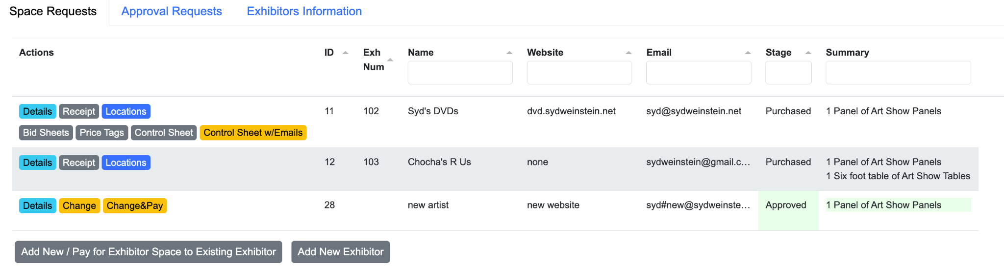

Each row shows an exhibitor that has requested space and its current status. The Actions column lists the actions you can perform on this row.

Note: all approval / change actions will email the exhibitor to tell them of the change and request they pay the invoice.

Actions:

* Details: Information about the exhibitor

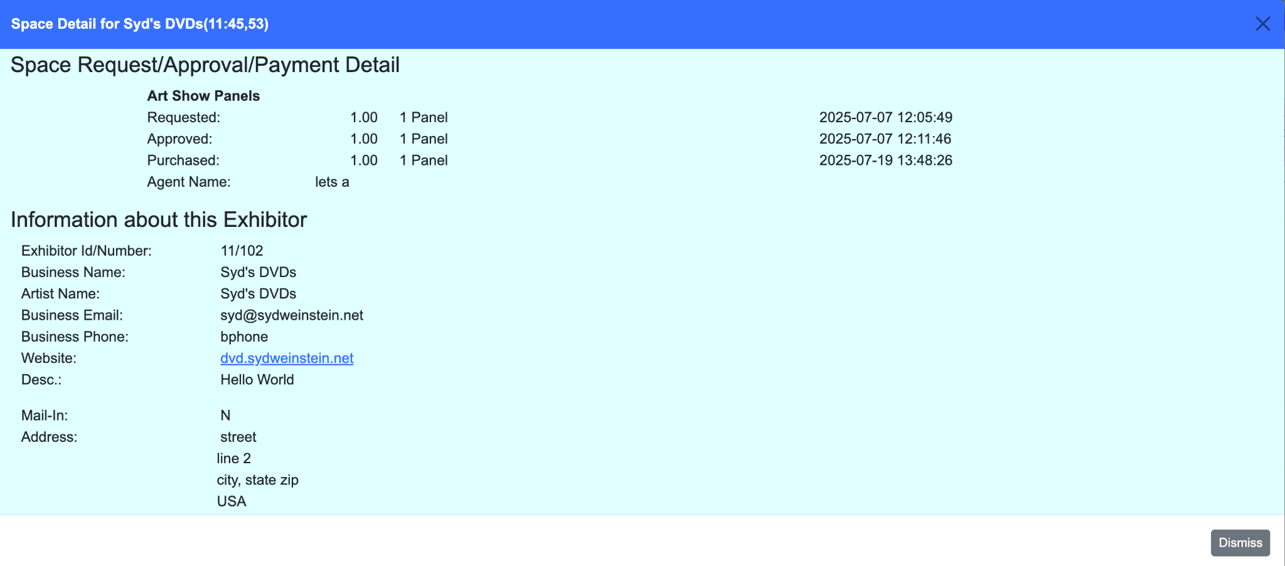

* Receipt: (Stage: Purchased) - The receipt for payment for the space.

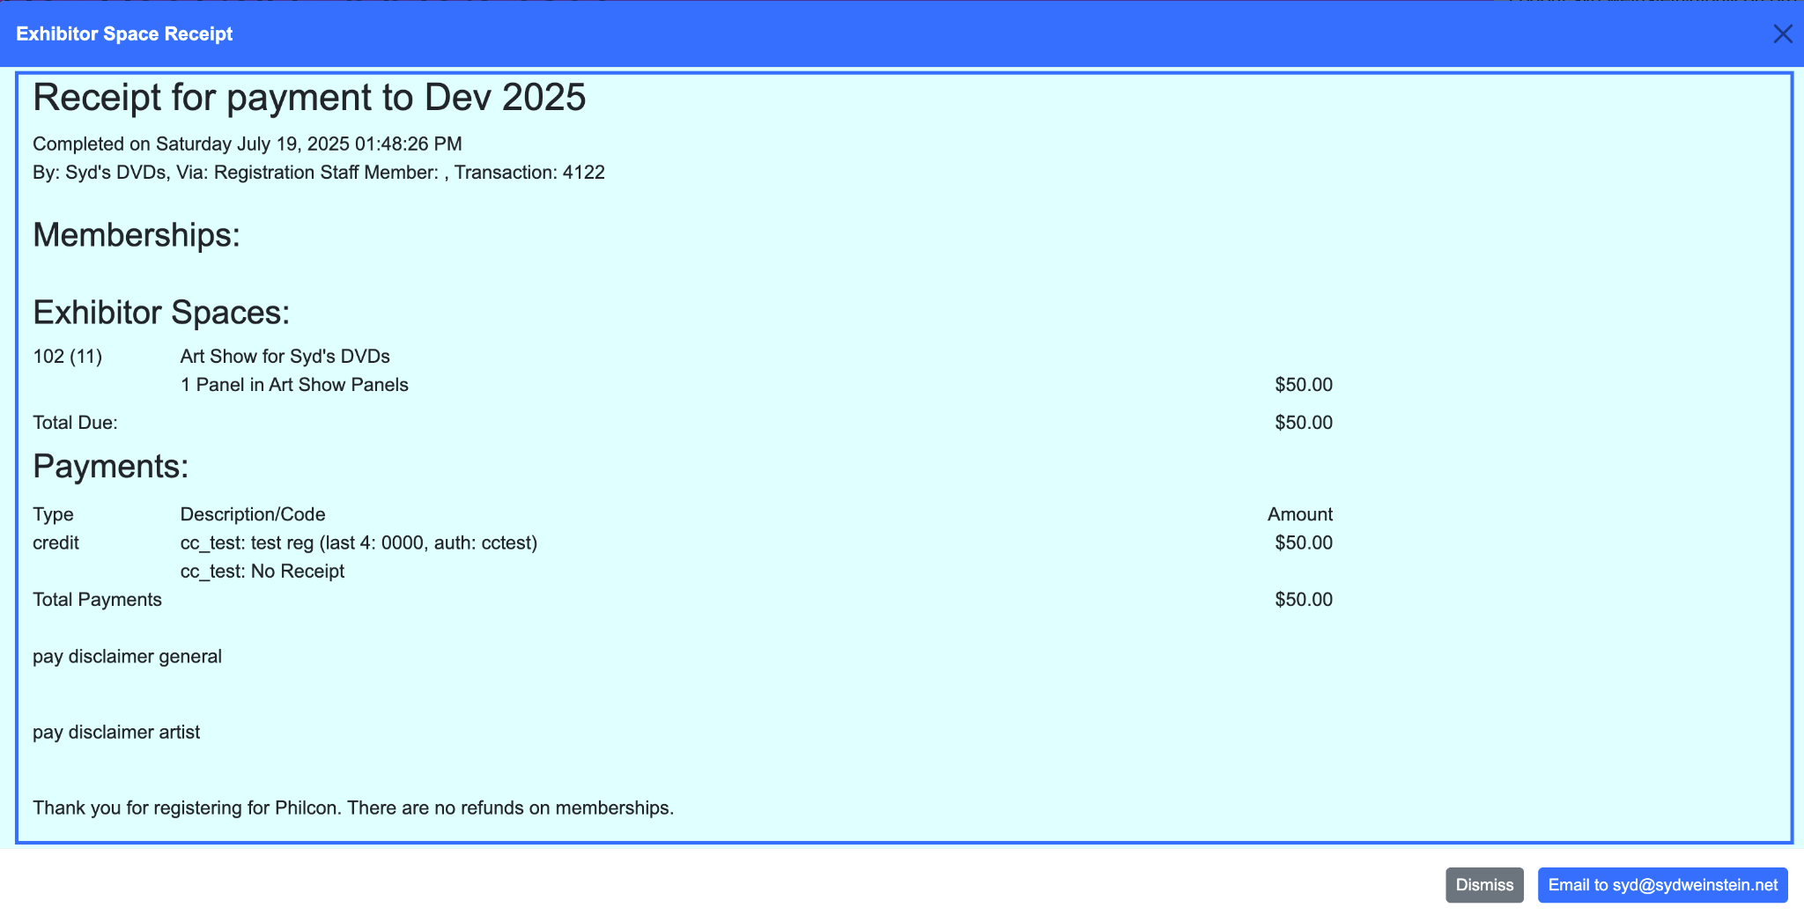

* Locations: (Stage: Purchased) - See/Assign locations to this exhibitor

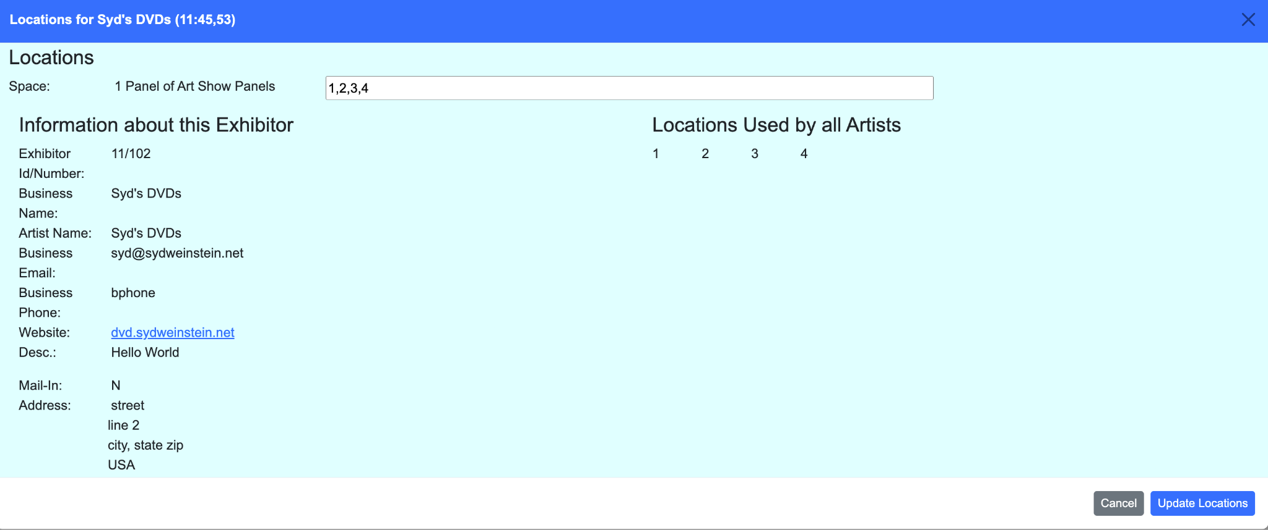

* Approve Req: (Stage: Requested) - Approve the request as shown on the line. This button takes immediate effect and does not need to open a popup window.
* Approve Other: (Stage: Requested) - Open a pop-up window the edit the request and approve a different set/amount of space.

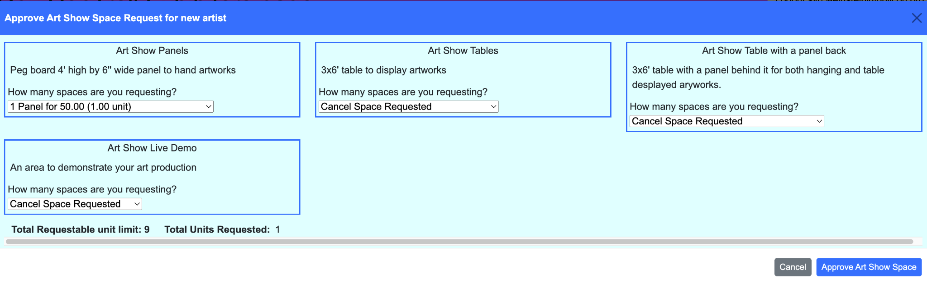

* Change: (Stage: Approved) - Open the same pop-up window as above to change the approved, but unpaid for space.
* Revert to Orig Req: (Stage: Approved) - If the original request is different than the approved request, change it back to the original request. No pop-up window is required.
* Change&Pay: (Stage: Approved) - Verify/change the space approved and proceed to process a mail-in payment or mark no-charge space paid.
* Bid Sheets: (Stage: Purchased) - Display the bid sheets in a new tab for viewing or printing
* Price Tags: (Stage: Purchased) - Display the print price tags in a new tab for viewing or printing
* Control Sheet: (Stage: Purchased) - Display the control sheet in a new tab for viewing or printing
* Control Sheet w/Emails: (Stage: Purchased) - Display the control sheet also showing the winning bidders email address in a new tab for viewing or printing

The rest of the columns are for display only. The stage and summary of space is color coded.

* None: Purchased
* Pale Blue: Requested
* Pale Green: Approved

At the bottom of the table area are two buttons:

* Add New/Pay for Exhibitor Space to Existing Exhibitor: This lists all existing exhibitors who have not yet requested space in this region.

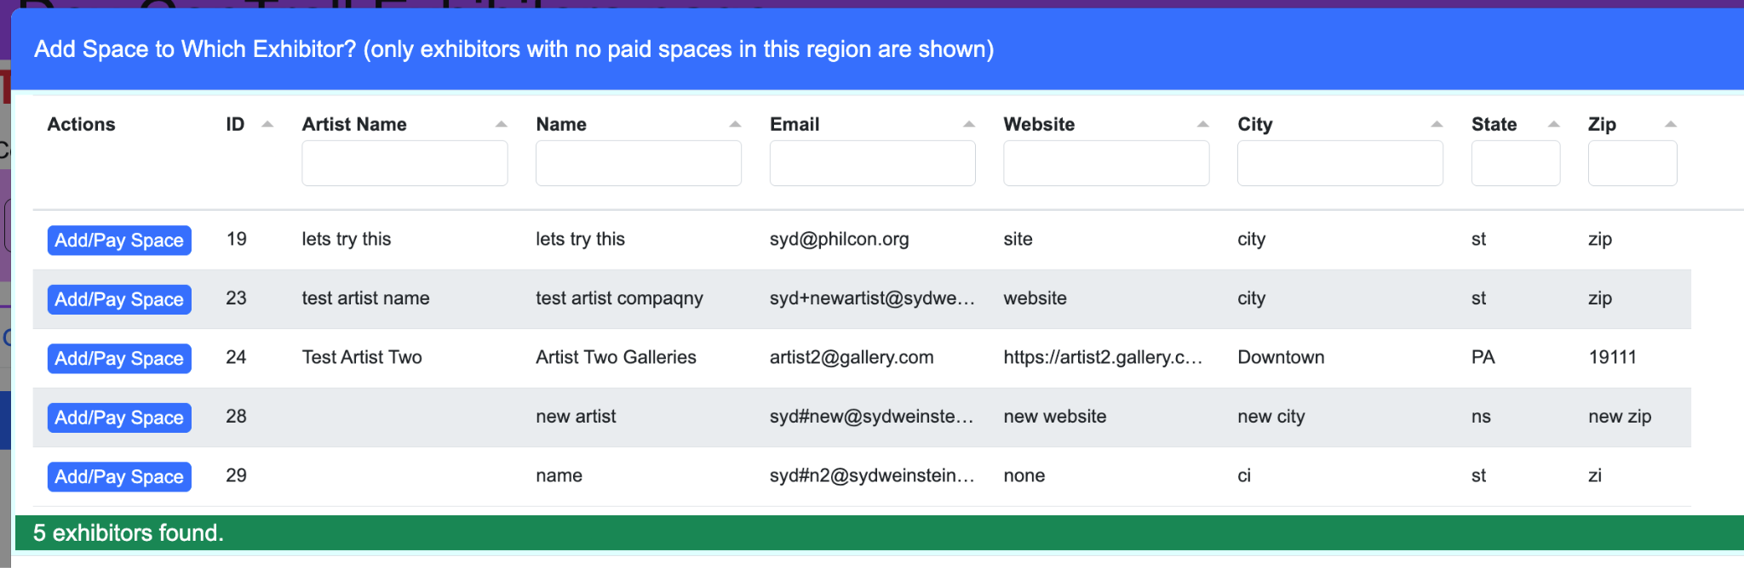

Clicking Add/Pay Space will open the select space pop-up and walk through from there the approval and payment processes. You can stop without paying for the space if desired. This is designed for no charge spaces and for mail in registrations.

* Add New Exhibitor: This opens the profile screen and allows direct entry of a new exhibitor to the system. From there it will then walk through the Add/Pay Space as above.

### Approval Requests

This tab, if the region supports approval requests, processes approval requests.

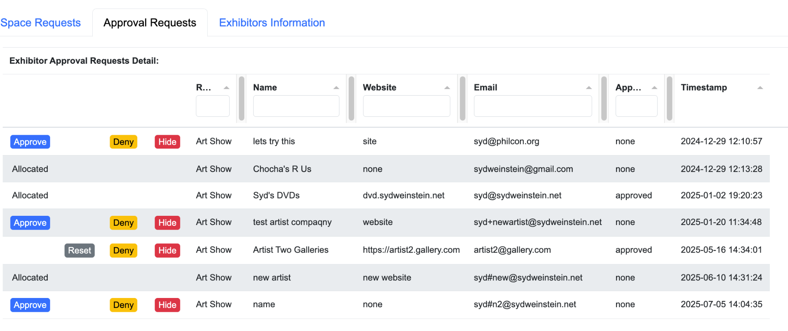

There are four possible actions one can perform on each request:

* Approve: Approve the request to apply. The requestor is notified via email.
* Reset: Reset the request to pending status.
* Deny: Deny the request. The requestor is notified via email.
* Hide: Hide the request, similar to Deny except the request is hidden from the screen and the requestor is not notified.

### Exhibitors Information

This tab shows you a summary of all exhibitors for this year. This list is for ALL exhibitors not just ones for your region.

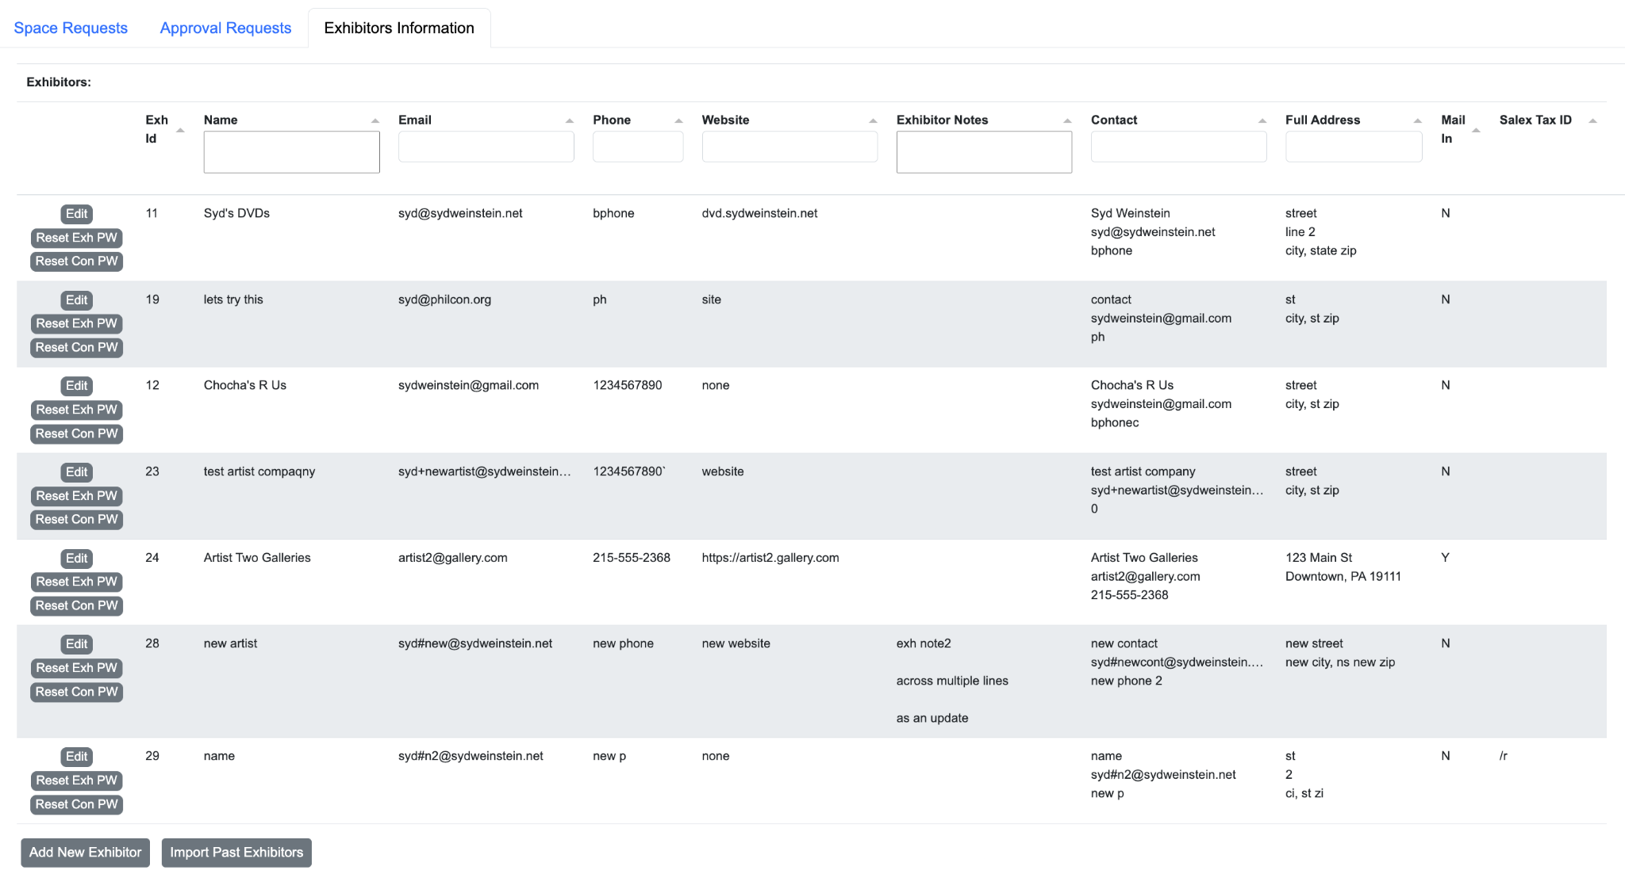

There are three actions available for each exhibitor:

* Edit: Opens the edit profile window allowing you to edit any field for the exhibitor entry.
* Reset Exh PW: Opens a modal popup with a new password for this exhibitor. Copy this password and send it to the exhibitor. This becomes their ‘temp/old password’. Note: once you dismiss the modal popup you will not be able to see the password again. If you lose it, just change it again.
* Reset Con PW: Opens a modal popup with a new password for this primary contact. Copy this password and send it to the primary contact. This becomes their ‘temp/old password’. Note: once you dismiss the modal popup you will not be able to see the password again. If you lose it, just change it again.

In addition there are two global actions at the bottom of the table:

* Add New Exhibitor: Open the profile window and create an entirely new exhibitor.
* Import Past Exhibitors: Only exhibitors who have logged into the portal this year are shown in the three tabs for this region. If an existing exhibitor has not yet signed in, you need to import them into this year. Click this button to find all non-active exhibitors.

A pop-up window will appear allowing you to select rows to import and an “Import Selected Past Exhibitors” button to perform the import.

# Inventory Management in ConTroll

Art inventory is managed by the exhibits administrator in the ConTroll back end using the “Art Control” menu item.

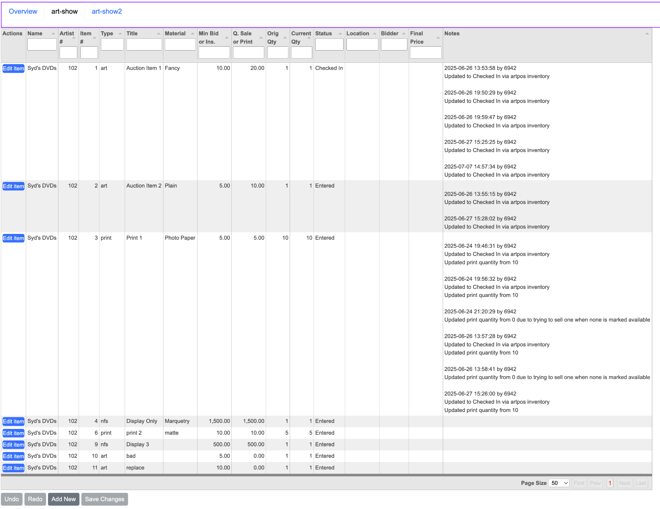

The top tab bar lists each of the inventory control regions. Select the region to edit and the page displays all the items for that region. The data can be edited using the edit button on the front of the item line. This opens an edit window:

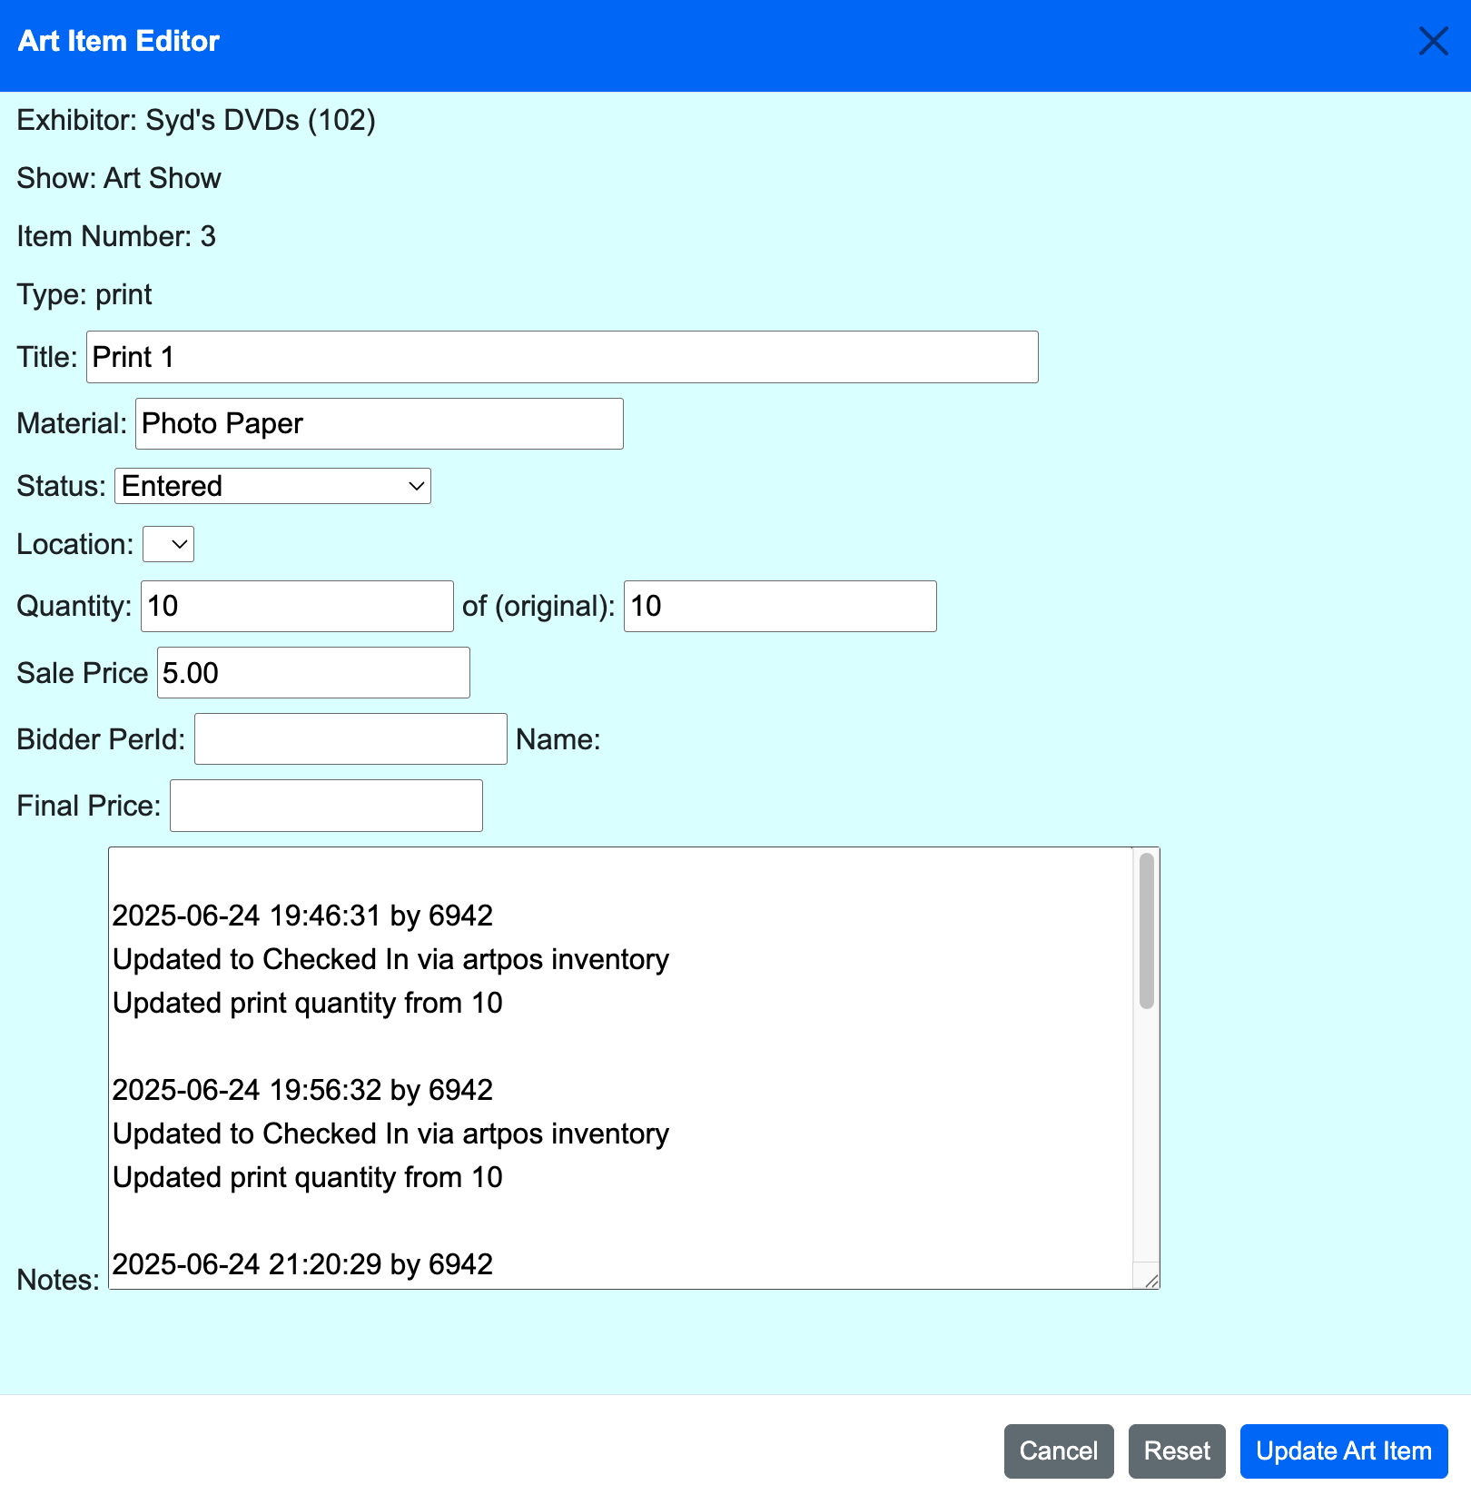

Any changes to fields not shown as input fields requires having the artist go in and delete the item and re-enter it. Artists can only delete items in the “Entered” state so before asking them to do so make sure it is in that state.

Updating the art item only saves it back to the table, you still need to save the changes to the table back to the system.

The “Add New” button at the bottom of the table will add a new item to the table. Leave the item number 0 to auto assign it, or set an unused number for the artist. Once that is selected the edit screen is shown to fill in the rest of the fields.

1. There are plans to shortly replace the temporary password with a reset password link that will just let them set a new password. This link would be one use, and have an expiration time. To prevent spamming someone, only one reset link email will be sent until the time limit has expired and a new one can be requested. The user will be informed of the expiration time when requesting another lin..
2. One or more of these will display. This example has some sample text showing all 3 blocks. The first two disclaimer blocks are custom text items: exhibitor-index-request-disclaimer followed by one of the four “portal type” disclaimer blocks: exhibitor-index-request-disclaimer* (Artist, …). If the block contains the default message, the disclaimer block will not be shown. It is not necessary to use both the general and the portal specific disclaimer. Use what works for your convention.
3. The text in the pulldown comes from the item description field in the configuration.
4. The paragraph about memberships is fixed text and not configurable.
5. A copy of this email is also sent to the “owner email” address configured in the “Regions for this Year” tab.
6. See the Space Requests tab in “Regions” tab in controll’s exhibitors page.
7. The prompt for the sales tax id comes from the configuration file. If the prompt is the empty string, the field is suppressed.
8. The disclaimer shown comes from the pay_disclaimer custom text items, similar to the req_disclaimer items in custom text.
9. The disclaimers in the receipt come from the pay_disclaimer custom text items, similar to the req_disclaimer items in custom text.